Table of Contents
Overview 2
Application Processing (AP) 3
Entering Provider Information 4
Application Processing (AP) 5
Case Processing (CP) 6
Building HCBS Categories 8
Non-Financial 8
Resources 11
Income 12
Money Follows the Person (MFP) 13
Transferring from a HCBS Program to an LTC Facility 15
Transferring from a LTC Facility to a HCBS Program 16
Nursing Home Transition (NHT) 18
Rejecting HCBS for an Individual who is not Medically Eligible 24
Adding HCBS to an Open SNAP Case 27
AUTHORIZING HCBS IN A NON-LTC CATEGORY OF MA 31
Adult Community Autism Program (ACAP) Requests 31
Spend-down Requests 31
Non-LIFE HCBS 32
LIFE HCBS 34
Non-Citizens Applying for HCBS 37
Entering a Waiver Code in an Open Disabled Adult Child (DAC) Case (Non-Financial Override) 39
Authorizing HCBS Applicants in a Medical Assistance for Workers with Disabilities (MAWD) Category 41
Establishing a Penalty Period 42
HCBS Applicants 43
HCBS Recipients 47
Manual Adjustments to the 903Q TPL 51
Modification and Negation: 51
MANUAL NOTICES 54
UNDUE HARDSHIP WAIVER NOTICES…………………………………………………………………………………………………55

Overview
The purpose of this desk reference is to consolidate instructions for authorizing and maintaining waivers in eCIS into one manual. The Long-Term Care Handbook should be utilized when policy questions arise.
Screen shots in this reference were created using a testing environment. Therefore, all screen names begin with an ‘S’ instead of a ‘C’ as in production.
Waiver Categories
Valid waiver codes for PAW 80/66/00 are 20, 51, 52, 68, 77, 79, 81, 96
Valid waiver codes for PJW 80/66/00 are 20, 51, 52, 68, 70, 77, 79, 81, 96
Valid waiver codes for PMW 80/66/00 & PCW 02 are 20, 68, 77, 79, 81, 96
PAW 80 | A recipient of HCBS who is age 65 or older and is enrolled in buy-in. This category provides payment for the Medicare Part B premium, co-insurance, and Medicare deductibles.
PAW 66 | A recipient of HCBS who is age 65 or older and is enrolled in buy-in. This category provides payment for the Medicare Part B premium.
PAW 00 | A recipient of HCBS who is age 65 or older and is not enrolled in buy-in.
PJW 80 | A recipient of HCBS who is disabled, under age 65 and is enrolled in buy-in. This category provides payment for the Medicare Part B premium, co-insurance, and Medicare deductibles.
PJW 66 | A recipient of HCBS who is disabled, under age 65 and is enrolled in buy-in. This category provides payment for the Medicare Part B premium.
PJW 00 | A recipient of HCBS who is disabled, under age 65 and is not enrolled in buy-in.
PMW 80 | A recipient of HCBS who is blind, age 21 through 64 and is enrolled in buy-in. This category provides payment for the Medicare Part B premium, co-insurance, and Medicare deductibles.
PMW 66 | A recipient of HCBS who is blind, age 21 through 64 and is enrolled in buy-in. This category provides payment for the Medicare Part B premium.
PMW 00 | A recipient of HCBS who is blind, age 21 through 64 and is not enrolled in buy-in.
PCW 02 | A recipient of HCBS who is a refugee.
Reminder: SSI is a cash program. SSI recipients with a C01: Current pay status in the Payments tab on the Exchange 6 SDX Match Details screen who are eligible for payment of HCBS should remain open in an SSI category.

Application Processing (AP)
All applications received in the CAO must be registered in the AP subsystem for tracking and reporting purposes prior to processing eligibility in eCIS.
During AP, clerical staff should choose ‘Medical Assistance Waiver’ as opposed to ‘Medical Assistance’ when entering the application information on CAPINF, the Application Information screen. This allows for correct tracking of waiver applications in AP and ensures eligibility for payment of HCBS is determined correctly. ‘MA’ will still be displayed on the Program Request screen.

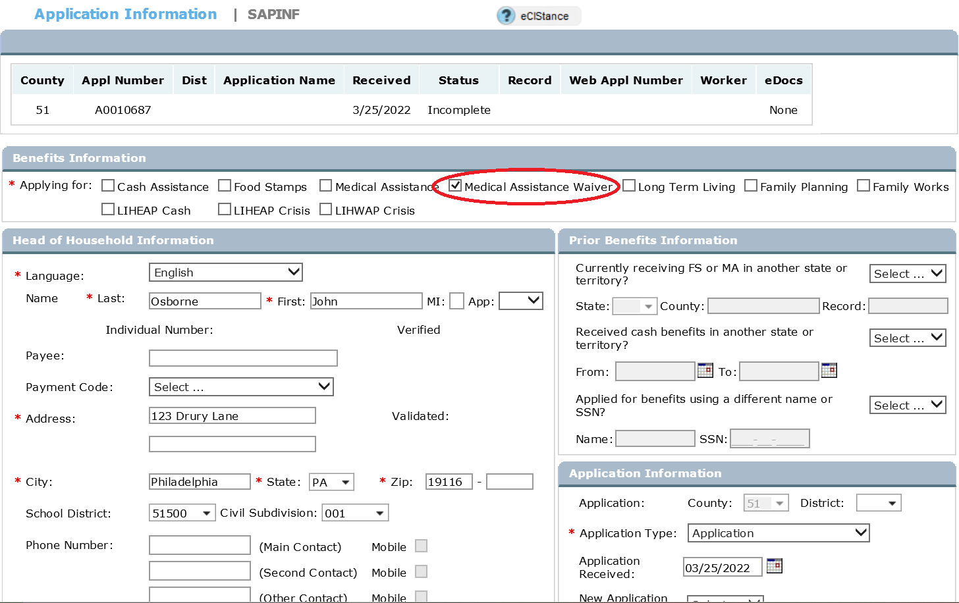

Entering Provider Information
It is imperative that the individual as well as all involved parties be kept informed of any changes to a waiver applicant’s or recipient’s eligibility. In addition to sending a notice to the individual the CAO must also send copies of all notices to:
- the individual’s representative(s) including any service coordinator or entity listed on the Home and Community Based Services Eligibility / Ineligibility / Change Form (PA 1768);
- the Independent Enrollment Broker (IEB) or enrolling agency that initially determined functional need as listed on the PA 1768
- the Office of Long-Term Living (OLTL) at:

LIFE/Forum Place 6th Floor
P.O. Box 8025
Harrisburg, PA 17105-8025

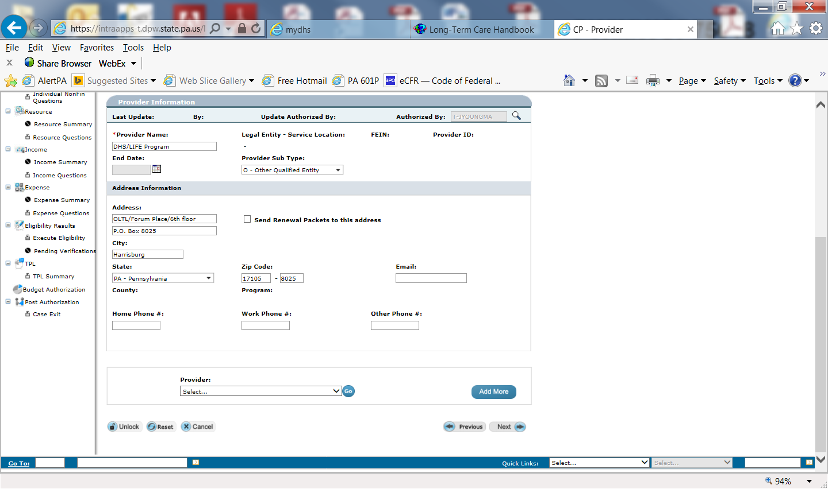
Provider information reported on applications can be entered either by the clerical worker in AP or the caseworker in Case Processing (CP).

Application Processing (AP)
Clerical has the ability to add provider identification numbers while in the AP mode. Entry of a provider number in AP schedules an automated notice to be sent to the provider. The caseworker can add additional providers to the record using the Provider screen in CP.
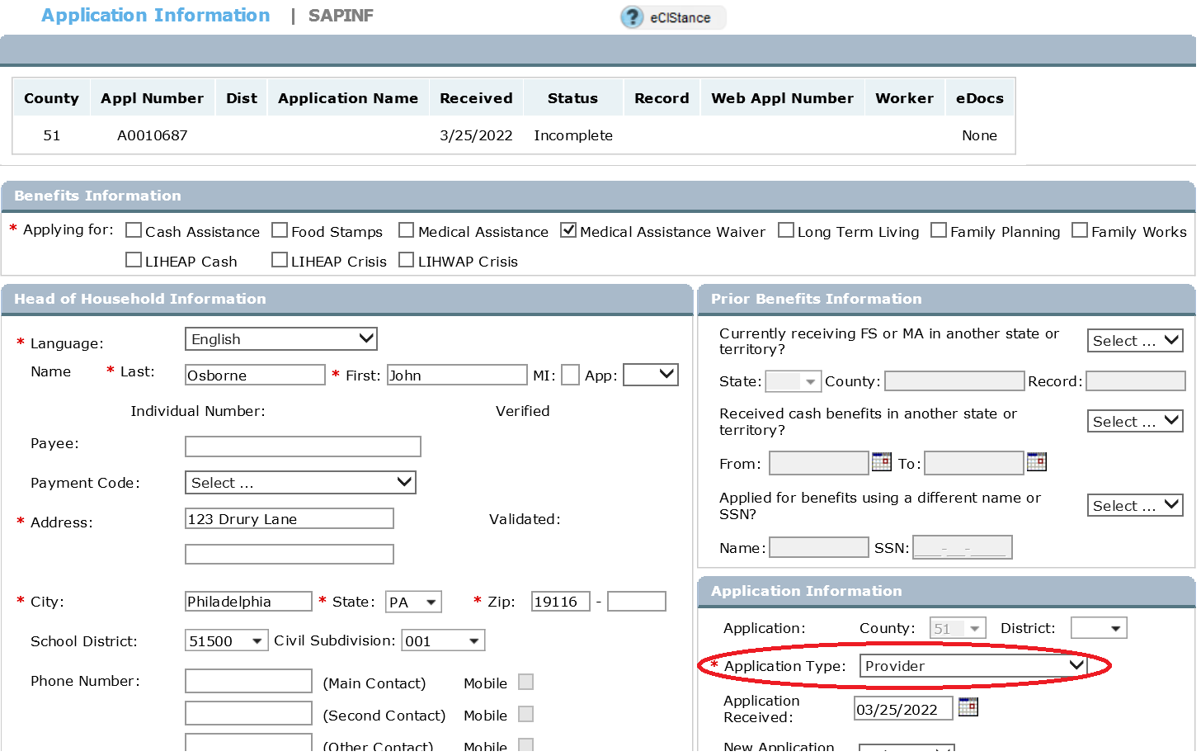

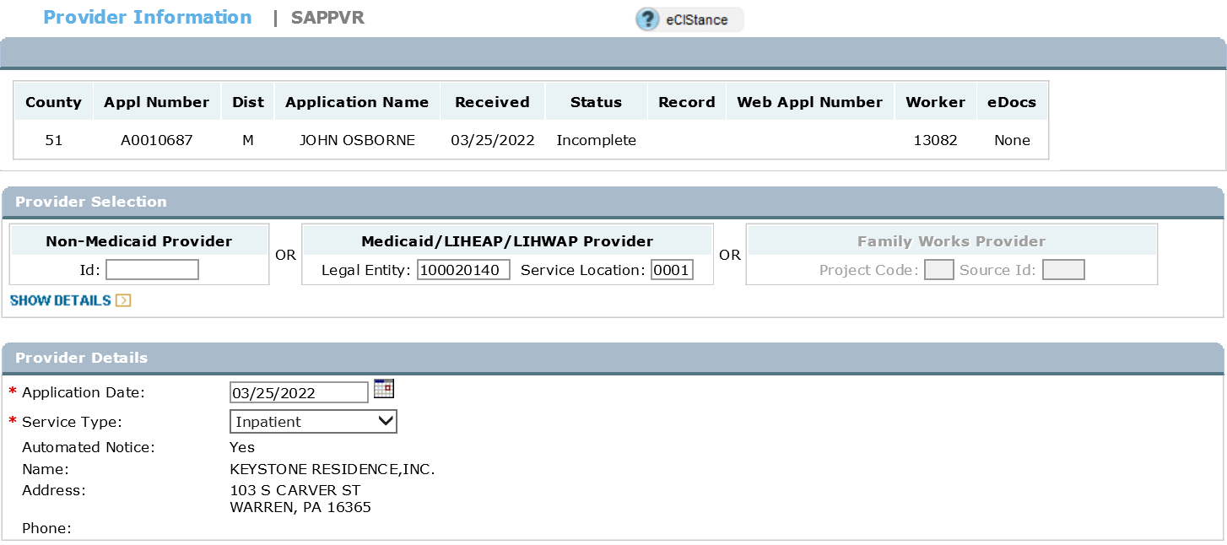

Case Processing (CP)
In all cases AP’d in a ‘MAW’ or ‘MA’ category the IMCW must enter a ‘Y’ in the ‘Add/ Modify Provider’ field on the Household screen in order to schedule the Provider screen.
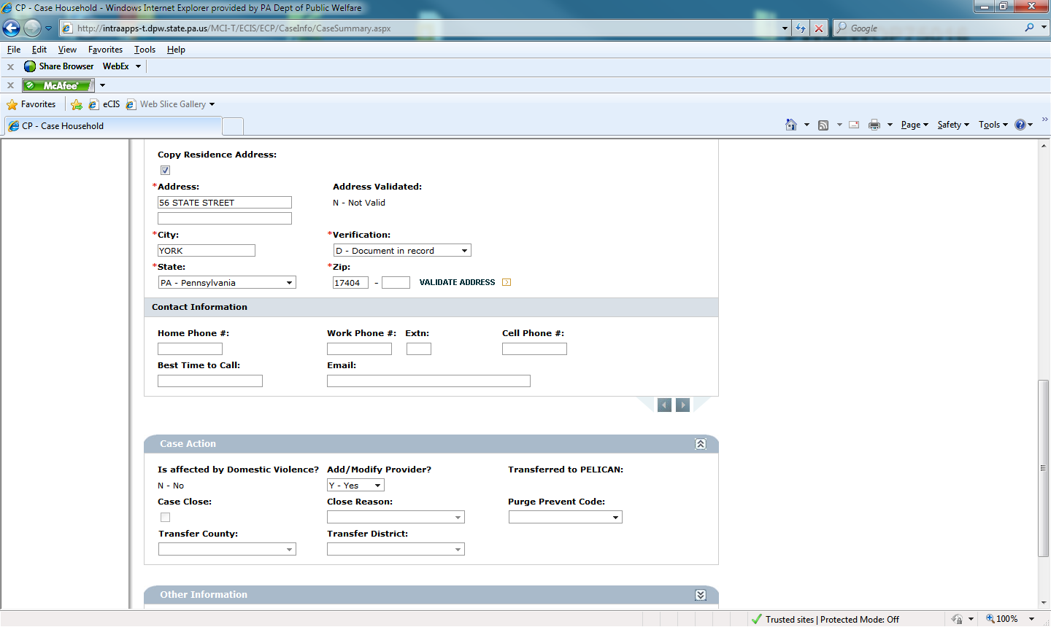

A provider entered during AP will be displayed on the Provider screen. The ‘Add More’ button is used to enter more than one provider. Enter the individual’s representative(s), IEB and any other entities that must receive a notice on the Provider screen.

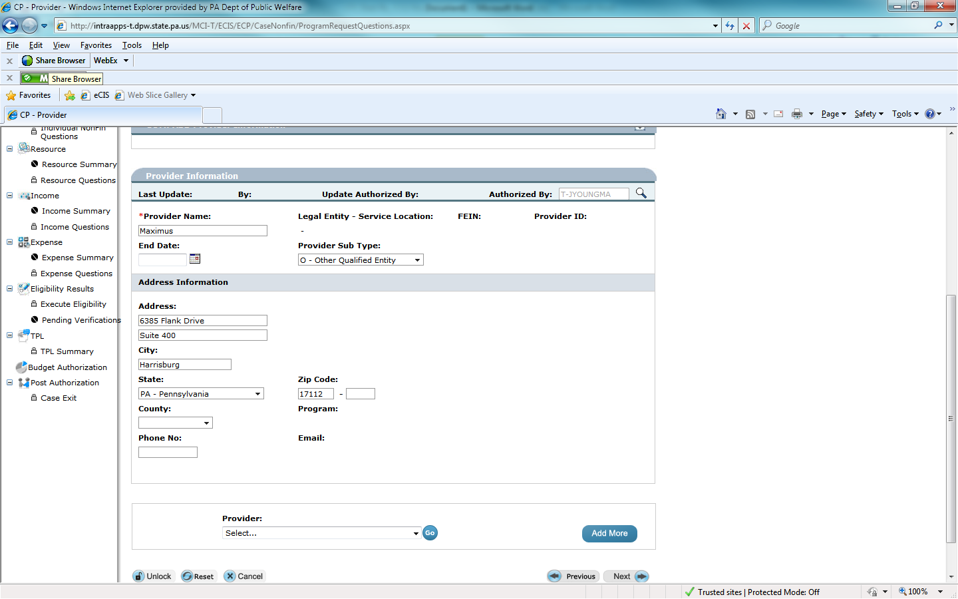

The providers entered in the case via AP and/or CP will be listed on the Post Authorization Client Notice screen. Each provider listed on this screen will receive a copy of the notice. The CAO can choose not to send a specific notice to one or more of the providers listed by deselecting any or all of them.

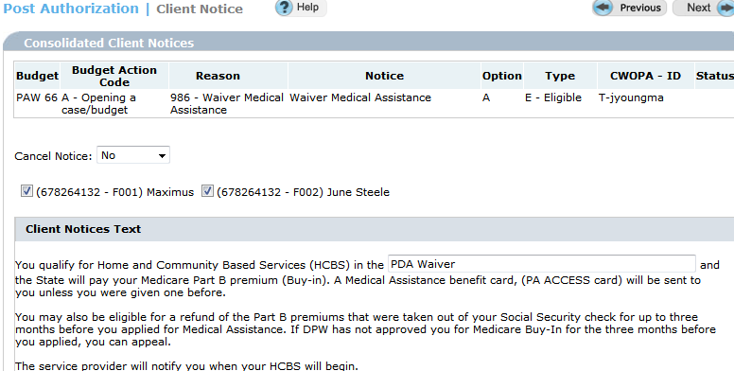

Building HCBS Categories
An individual must meet certain functional, financial and non-financial requirements in order to be authorized in a HCBS category. When the individual meets these requirements, there are certain fields in eCIS that must be entered in order to build a waiver category.

Non-Financial
In eCIS answers to questions on the Individual Attributes and Non-Financial Questions screens drive creation of the appropriate waiver category. If these questions are not answered correctly eligibility will be determined in the wrong category.
On the Individual Attributes screen the ‘Entitled to Medicare (Part A)’ and the ‘Medicare Part A Recipient’ fields must be checked if the individual is eligible or entitled for and/or receiving Medicare A.
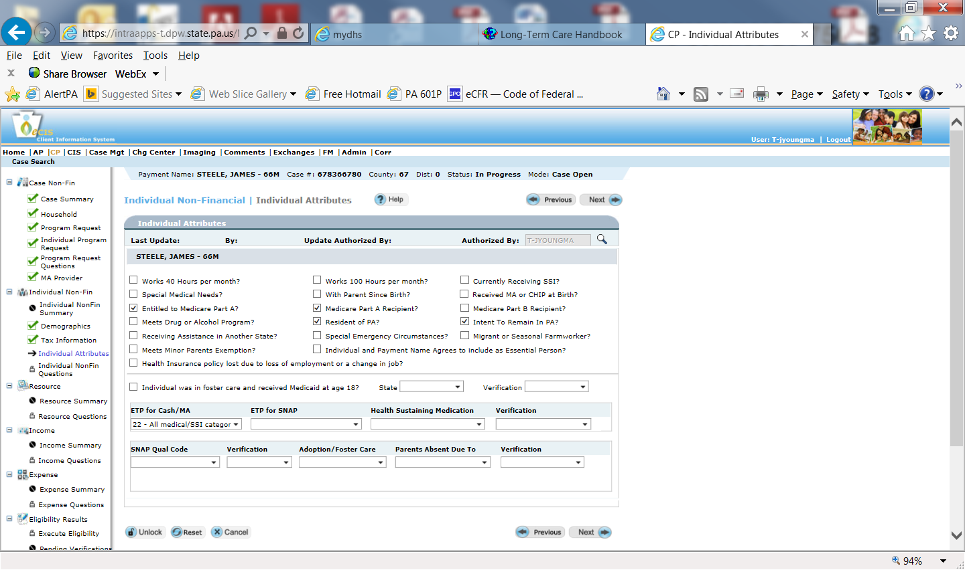

If the individual is also eligible for and receiving Medicare Part B, check the third box as well.
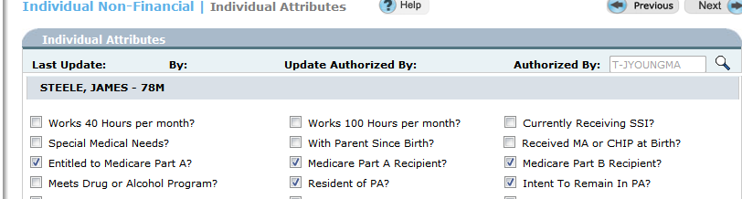

On the Non-Financial Questions screen a ‘Y’ must be entered in the ‘Waiver Services’ field in order to schedule the Waiver screen.
Reminder: If the individual is under age 65 then a ‘Y’ must be entered in the ‘Disability or Incapacity’ field and the Disability screen must be completed in order to build a waiver category.
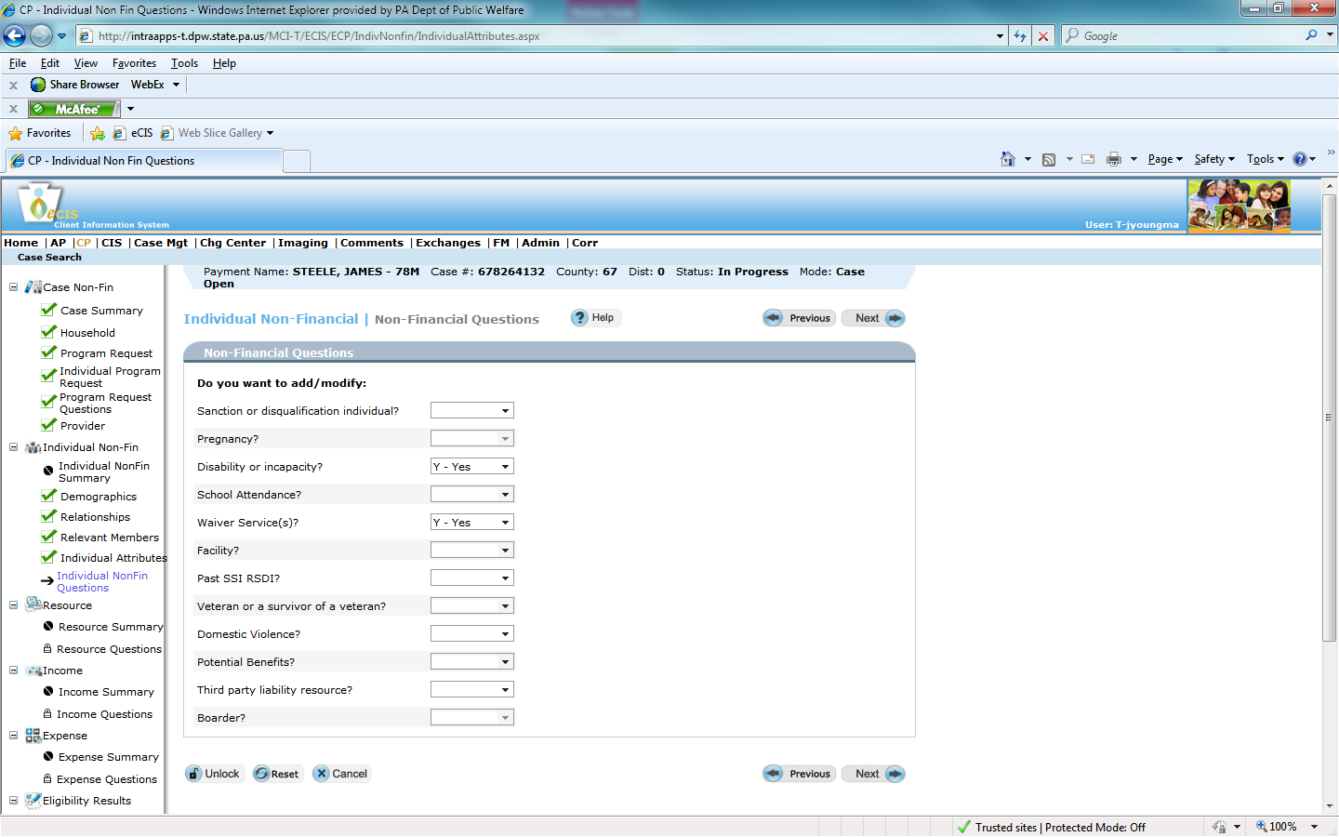
On the Waiver screen, use the Assessment Date if it’s the only date listed or the Service Begin Date, if both the assessment and service begin dates are listed on the PA 1768 as the waiver begin date for all other waivers, except Community HealthChoices waiver code 20.
CHC waiver must have a begin date of the date the CAO processes the application on the waiver screen.

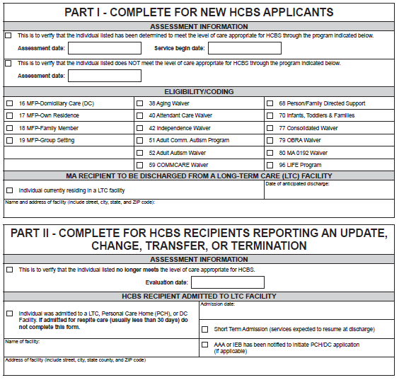
For LIFE Program (waiver code 96) enrollment, the Service Begin Date should be entered as the waiver begin date.

Reminder: Effective dates of two waiver codes cannot overlap in eCIS. If the CAO receives a PA 1768 requesting that one waiver code end and a second begin on the same day, the CAO must call the Independent Enrollment Broker (IEB) or assessing agency listed on the PA 1768 for clarification. Entry of two waiver codes concurrently will cause billing issues.
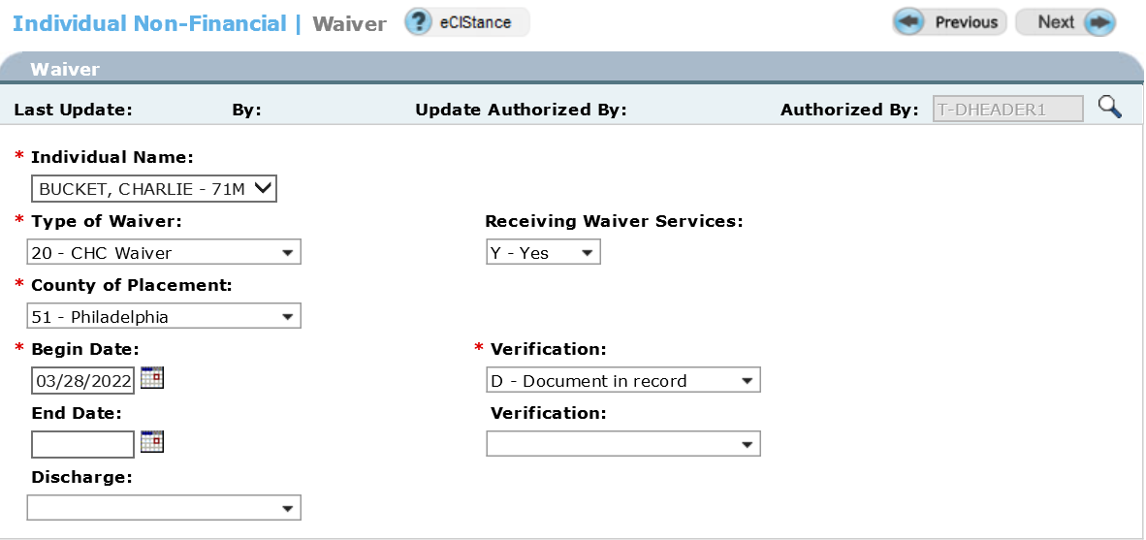

Entry of information on the Waiver screen will schedule the Long-Term Living (LTL) screen.
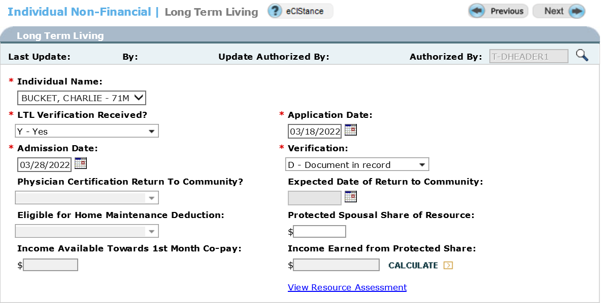

Resources
All countable resources of both the institutionalized spouse and community spouse must be entered in eCIS in order to determine the correct category. Although the resources of the community spouse are not used to determine eligibility for payment of HCBS they are used to determine the institutionalized spouse’s eligibility for Buy-In. For current Buy-in Resource limits see the Long-Term Care Handbook Chapter 488, Appendix A.
When an individual is authorized in a buy-in category the total countable resources of the individual and spouse are compared to the two-person buy-in resource limit on the Resource Eligibility Results screen. In the example below the institutionalized spouse is eligible for buy-in as a category PAW 66 because combined countable resources are less than the two-person buy-in resource limit.
Reminder: Resources of the community spouse are only used to determine eligibility for buy-in. When the institutionalized spouse is authorized in a category that does NOT include buy-in (PAW/PJW 00/PMW00) only the resources of the institutionalized spouse will be displayed on the Resource Eligibility Results screen.
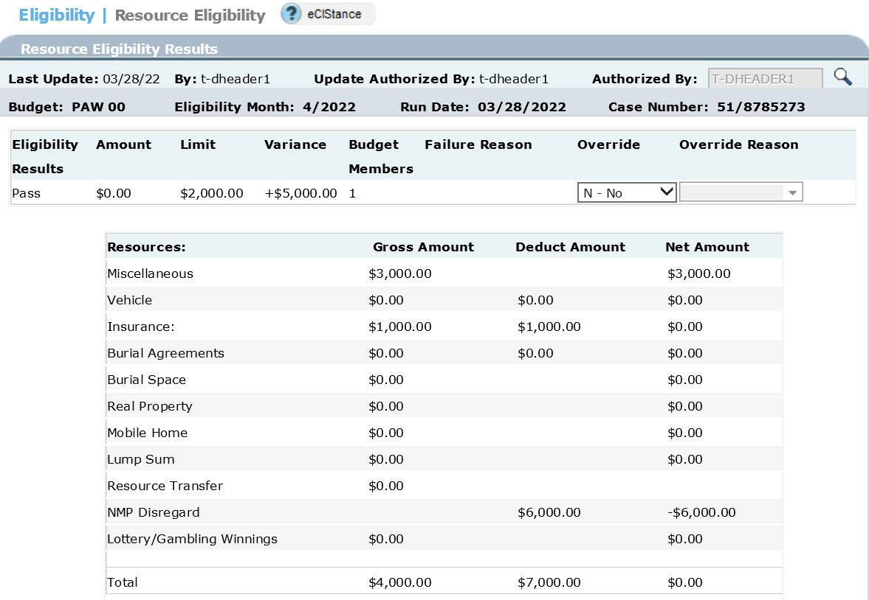

Income
Income of both the institutionalized spouse and community spouse must be entered in eCIS in order to determine the correct category. Although the income of the community spouse is not used to determine eligibility for payment of HCBS and HCBS programs have a zero cost of care (unless income spend-down is required), the income is used to determine the institutionalized spouse’s eligibility for Buy-In. For current Buy-in Income limits see the Long-Term Care Handbook Chapter 488, Appendix A.
When an individual is authorized in a buy-in category the total combined income of the individual and spouse is compared to the two-person buy-in income limit on the Income Eligibility Results screen. In the example below the institutionalized spouse is eligible for buy-in as a category PAW 66 because the total married couple’s net income is less than 120% of the two-person Federal Poverty Income Guidelines (FPIGS).
Reminder: Income of the community spouse is only used to determine eligibility for buy-in. When the institutionalized spouse is authorized in a category that does NOT include buy-in (PAW/PJW 00/PMW00) only the income of the institutionalized spouse will be displayed on the Income Eligibility Results screen.

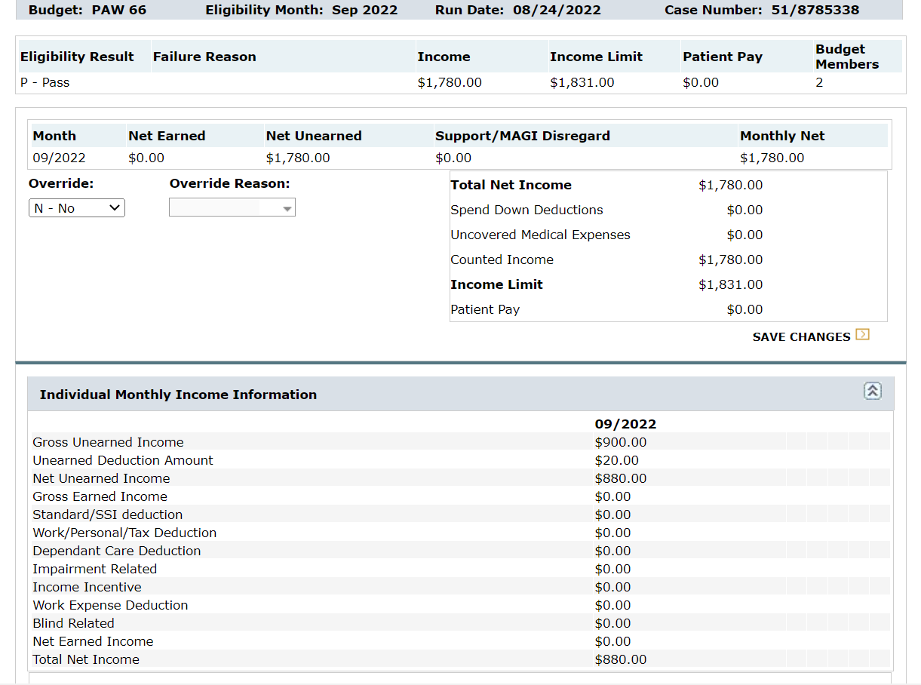

Money Follows the Person (MFP)
Money Follows the Person (MFP) is a federally funded demonstration project that provides enhanced federal funding of certain qualified services provided to individuals who transition back to the community under a HCBS program. Eligibility for MFP is designated through the use of an MFP facility code on the PA 1768. It is very important to review the PA 1768 for MFP eligibility as well as eligibility for HCBS. The MFP facility codes are 16, 17, 18, and 19 depending on the individual’s type of residence. The individual must be simultaneously eligible in one of the designated waivers in order to be eligible for MFP.
Reminder: eCIS will not allow concurrent entry of two facility codes. When an individual transitions from a LTC facility to HCBS with MFP; the LTC facility code is end dated the date of discharge listed on the MA 103 Admission/Discharge/Transmittal form received from the LTC facility or on the PA 1768. The most accurate effective date of the waiver code is the service begin date listed on the PA 1768. Usually the waiver begin date is the same date as the LTC facility discharge date. eCIS allows the MFP code and the LTC facility code to overlap 1 day.
To authorize an individual who is transitioning from an LTC facility to a HCBS Program and MFP in the community:

- Access the Individual Non-Financial Questions screen through maintenance mode and enter a “Y” for “waiver”, “facility”, and depending on the individual’s age, for “disability”.

- Enter the HCBS waiver code and begin date on the Waiver screen.

- Enter the end date and discharge code for the individual’s previous institutionalization. Leave the “explore LTC” field blank. Choose to “Add More” to schedule a second Facility Placement screen.

- Enter the MFP placement code, MFP begin date, and an “N” to “explore LTC” on the second Facility Placement screen.

Please see Ops Memo 21-04-01 for more information regarding how to process MFP eligibility and how to end date the MFP code in eCIS.
See PMN-20780-403 for further instructions if a CAO receives MFP notification through their RA account.

Transferring from a HCBS Program to an LTC Facility
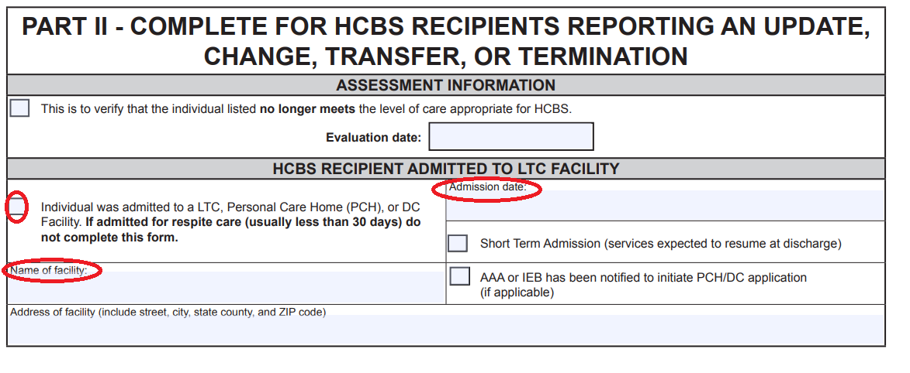
When the CAO receives a PA 1768 verifying the HCBS recipient was admitted to an LTC facility, budget action should be based on the information reported on page 3.

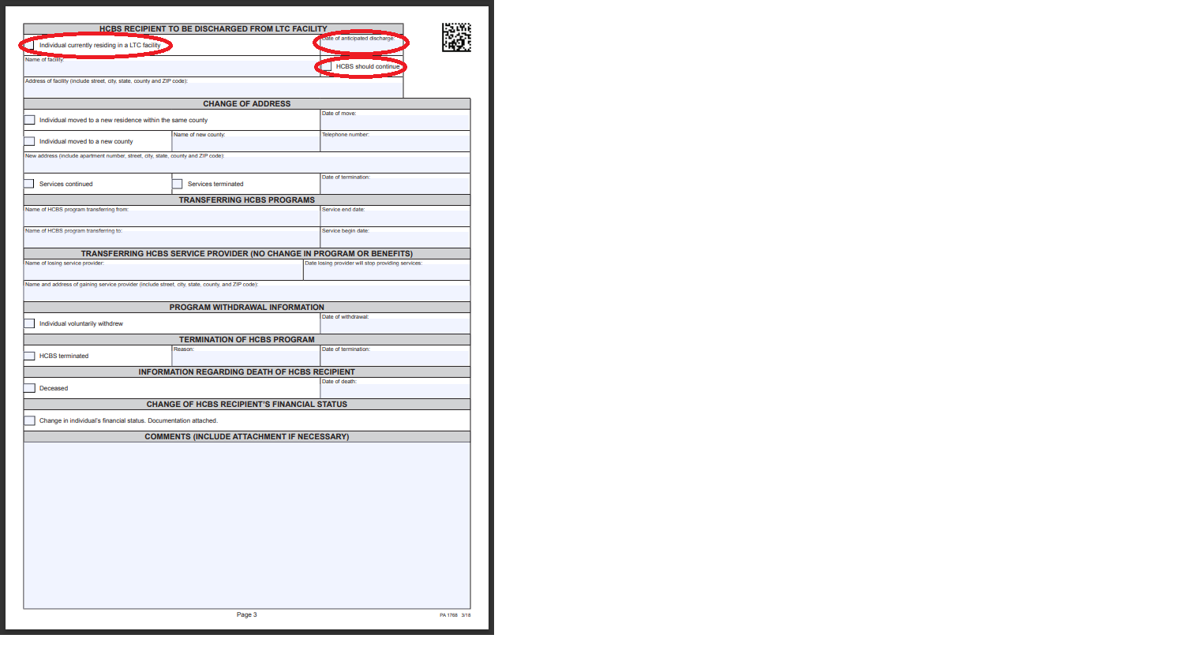

Reminder: CAOs cannot end a LIFE Program (waiver code 96) based only on a facility’s admission notification and must wait for the PA 1768 or collateral contact with the LIFE service provider. Once the participant resides in the LTC facility for 31 continuous days, the CAO must close the LTC waiver budget category and reopen an LTC facility budget category effective the first day of the month in which the 31st day of institutionalization occurred.
The system will end the 96 waiver code on the last day of the month in which processing occurs. As a result, the CAO must re-enter the 96 waiver code with a begin date on the first day of the following month in addition to:
- adding the 35/36 facility code,
- authorizing the PAN/PJN/PMN budget, and
- calculating a cost of care contribution which also begins on the first day of the month in which the 31st day of institutionalization occurred.

Transferring from a LTC Facility to a HCBS Program
NOTE: When the comments section of the PA 1768 indicates “Nursing Home Transition (NHT)” follow the procedures in the NHT section of this desk guide.
When the CAO receives a PA 1768 verifying the individual was, or soon will be discharged from a LTC facility and is eligible for HCBS the category can be changed from a LTC category to a waiver category in one step.

- Access the case through maintenance mode on the Case Summary screen.

- On the Household screen update the address to the individual's address in the community. Enter a ‘Y’ to add or modify providers.

- On the Provider screen enter additional providers, such as the IEB.

- On the Individual Non-Financial Questions screen enter a ‘Y’ for ‘Waiver’, ‘Facility’ and, if applicable depending on the individual’s age, ‘Disability’.
Reminder: If the individual is under age 65 then a ‘Y’ must be entered in the ‘Disability or Incapacity’ field and the Disability screen must be completed in order to build a waiver category.
- On the Waiver screen enter the waiver type and the begin date found on the PA 1768.

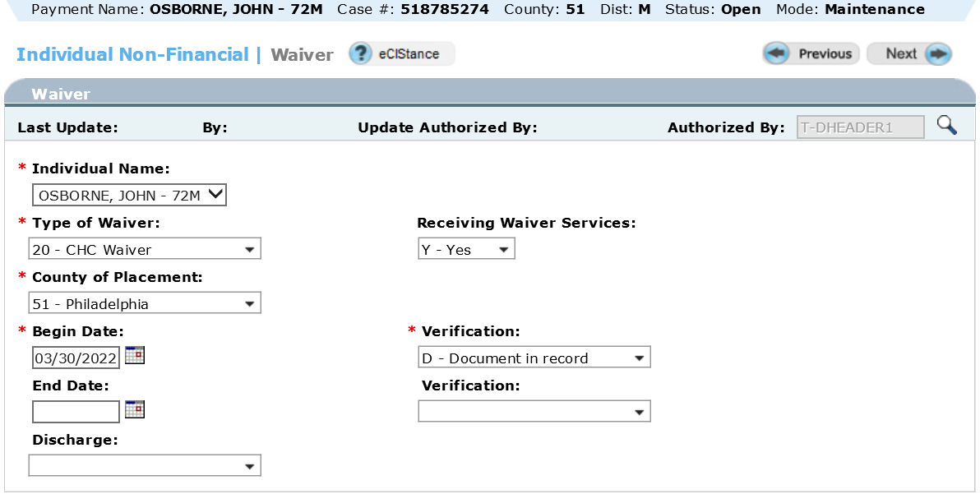
NOTE: The waiver begin date is usually the same day the individual is discharged from the LTC facility. eCIS allows concurrent entry of a facility and waiver code. The only exception is for CHC waiver, the begin date must be the CAO processing date unless it is indicated on the PA1768 it is Nursing Home Transition (NHT).
- On the Facility Placement screen enter the end date of facility placement, the discharge code and enter an ‘N’ for ‘explore LTL’.

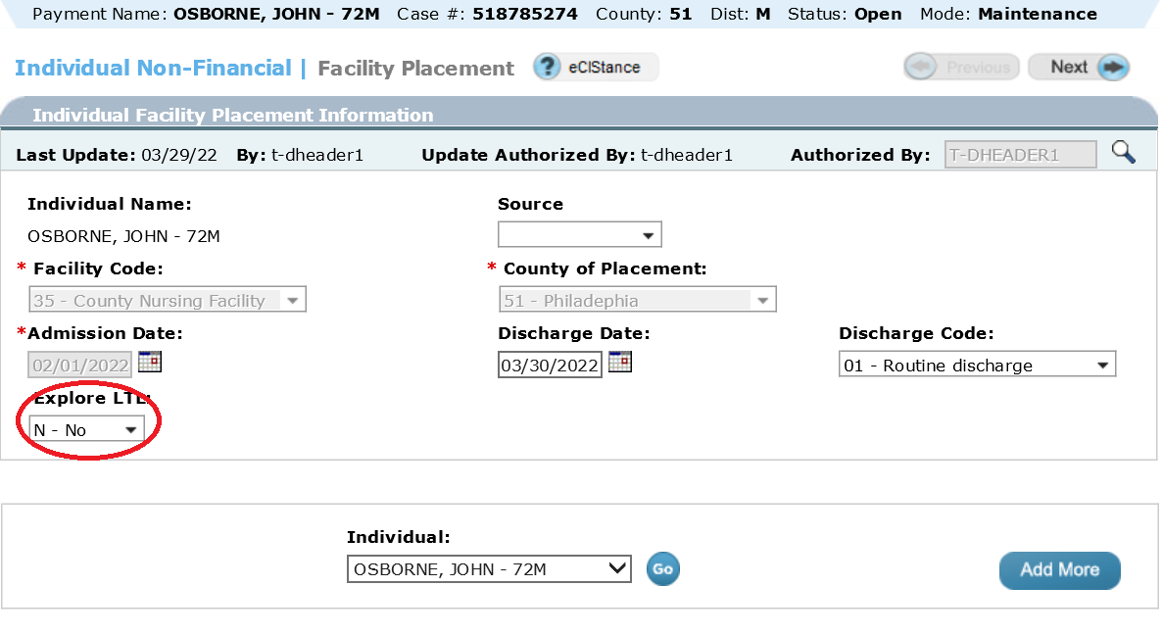

- Verify the appropriate reason code for closing the LTC category is displayed on the Notice screen. Workers may need to change the reason from 063 for voluntary withdrawal to 057/C for nursing home care not being provided.

NOTE: If eligible for payment of HCBS the effective date displayed in eCIS and on the notice of eligibility will be the date processed. This is not a problem because the automated notice states that the service provider will notify the individual when HCBS will begin. If the CAO wants the effective date on the notice to be the specific date listed on the PA 1768 then the LTC facility case must be closed and the waiver case opened in two separate transactions. By processing two separate transactions the effective date of HCBS displayed on the notice will match the date entered on the Program Request screen.

Nursing Home Transition (NHT)
When a LTC facility recipient who has a desire to return to the community is functionally eligible to return to the community with the help of supportive services provided through a waiver, a LTC transition coordinator will work with the client to seamlessly transition the client from LTC facility services to HCBS with no gap in coverage. The CAO will receive a PA 1768 with “Nursing Home Transition (NHT)” entered in the Comments section. NHT cases must be processed within five business days of receiving the PA 1768.

Adding a Waiver Code to the LTC Facility Budget
If a PA 1768 verifying NHT is received, the CAO will take the following steps within five business days:
- Review the case to ensure the client is financially eligible for HCBS. If not eligible for HCBS send a manual ineligibility notice and do not enter a waiver code.
- If the client is HCBS eligible enter the appropriate waiver code on the Waiver screen while keeping the LTC facility code open following these steps:
- In eCIS, enter Maintenance mode.

- Enter a “Y” for waiver services on the Individual Non-Financial Questions screen.

- Enter the waiver code from the PA 1768 on the Waiver screen with a ‘Begin Date’ matching the service begin date.

NOTE: When processing a NHT case, the Community HealthChoices (CHC) Waiver should be opened effective the service begin date even when it is a future date.

- Run eligibility. The facility budget will remain open with the waiver code, so that the individual will continue to receive LTC facility services until he or she is discharged.

- Send the appropriate notice to the individual and the individual’s representatives.

NOTE: The CAO must suppress the system generated waiver eligibility notice for individuals with an active penalty period, because it will display an incorrect waiver effective date. The CAO will need to send a manual notice with an effective date to match the ‘Begin Date’ entered on the Waiver screen. Notice templates are available here on Docushare or by navigating to ‘Statewide Forms’ -- ‘General Forms’ -- ‘Long Term Care Forms’ in Docushare.
For a penalty period due to a resource transfer, send a manual 986 L. In the detail section of the notice, the transferred amount is the amount that caused the original penalty period, found on the original 986 L notice. The date the client’s ineligibility for HCBS begins is the ‘Begin Date’ entered on the Waiver screen. The date the client’s ineligibility for HCBS ends is the original penalty period end date from the 903Q TPL.

For a penalty period due to excess home equity, send a manual 986 M. In the detail section of the notice, the CAO will enter the equity value of the home, found on the Real Property and Mobile Home screen in eCIS. The date the client’s ineligibility for HCBS begins is the ‘Begin Date’ entered on the Waiver screen.

NOTE: Do not send an Application for Undue Hardship Waiver (PA 1827) with this waiver penalty period notice. The individual was given the opportunity to request an undue hardship waiver when the penalty period was first established during the LTC facility application process.
Closing the Facility Budget
Once the CAO receives the LTC Admission and Discharge Transmittal Form (MA 103) verifying discharge the CAO will take the steps listed below based on whether the client was discharged on the anticipated waiver code begin date (timely discharge), earlier than the anticipated waiver code begin date (early discharge), or after the anticipated waiver code begin date (discharge less than 30 days after the anticipated date or more than 30 days after the anticipated date).
NOTE: If the IEB or Administrative Entity did not provide the PA 1768 indicating NHT prior to the CAO receiving the MA 103 notifying a facility discharge, the CAO must determine eligibility for HCBS retroactively back to the date of discharge from the facility, even for the CHC Waiver once the PA 1768 verifying NHT is received. If the individual needs to be opened for the CHC Waiver retroactive to the process date the CAO must take the following action to ensure proper CHC MCO enrollment:
Email RA-PWEnrollmentUnit@pa.gov with the following information:
• Master Client Index (MCI) number of the recipient
• First and Last name of the recipient
• Retroactive effective date of opening
• Date data entry was completed by the CAO
The CAO must take the appropriate action below within five business days.
- Timely Discharge:

- On the Facility Placement screen, enter the proper ‘Discharge Code’ and a ‘Discharge Date’ based on the information on the MA 103.

- Run eligibility. This will cause the facility budget to fail and the waiver budget to be authorized.

- Send the appropriate notice to the individual and the individual’s representatives.

NOTE: The CAO must suppress the system generated waiver eligibility notice for individuals with an active penalty period, because it will display an incorrect waiver effective date. The CAO will need to send a manual notice with an effective date to match the ‘Begin Date’ entered on the Waiver screen. Notice templates are available here on Docushare, or by going to Docushare and navigating to ‘Statewide Forms’ -- ‘General Forms’ -- ‘Long Term Care Forms’.
For a penalty period due to a resource transfer, send a manual 986 L. In the detail section of the notice, the transferred amount is the amount that caused the original penalty period, found on the original 986 L notice. The date the client’s ineligibility for HCBS begins is the ‘Begin Date’ entered on the Waiver screen. The date the client’s ineligibility for HCBS ends is the original penalty period end date from the 903Q TPL.

For a penalty period due to excess home equity, send a manual 986 M. In the detail section of the notice, the CAO will enter the equity value of the home, found on the Real Property and Mobile Home screen in eCIS. The date the client’s ineligibility for HCBS begins is the ‘Begin Date’ entered on the Waiver screen.

NOTE: Do not send an Application for Undue Hardship Waiver (PA 1827) with this waiver penalty period notice. The individual was given the opportunity to request an undue hardship waiver when the penalty period was first established during the LTC facility application process.

- Review the 902Z TPL to ensure it was end-dated to match the budget end date. If the TPL is not ended correctly or at all, the CAO will end date the TPL manually to match the budget end date.

- Early Discharge:

- In eCIS, enter Maintenance mode. Navigate to the Waiver screen.

- Negate the waiver by entering an ‘End Date’ that is one day prior to the ‘Begin Date.’

- Choose ‘Add More’ to schedule a new Waiver screen.

- Enter a ‘Begin Date’ matching the actual discharge date.

- Navigate to the Facility Placement screen. Enter the ‘Discharge Code’ and ‘Discharge Date’ based on the information on the MA 103. The ‘Explore LTL’ field should be blank.

- Run eligibility. This will cause the facility budget to fail and the waiver budget to be authorized.

- Send the appropriate notice to the individual and the individual’s representatives.

NOTE: The CAO must suppress the system generated waiver eligibility notice for individuals with an active penalty period, because it will display an incorrect waiver effective date. The CAO will need to send a manual notice with an effective date to match the ‘Begin Date’ entered on the Waiver screen. Notice templates are available here on Docushare, or by going to Docushare and navigating to ‘Statewide Forms’ -- ‘General Forms’ -- ‘Long Term Care Forms’.

For a penalty period due to a resource transfer, send a manual 986 L. In the detail section of the notice, the transferred amount is the amount that caused the original penalty period, found on the original 986 L notice. The date the client’s ineligibility for HCBS begins is the ‘Begin Date’ entered on the Waiver screen. The date the client’s ineligibility for HCBS ends is the original penalty period end date from the 903Q TPL.

For a penalty period due to excess home equity, send a manual 986 M. In the detail section of the notice, the CAO will enter the equity value of the home, found on the Real Property and Mobile Home screen in eCIS. The date the client’s ineligibility for HCBS begins is the ‘Begin Date’ entered on the Waiver screen.

NOTE: Do not send an Application for Undue Hardship Waiver (PA 1827) with this waiver penalty period notice. The individual was given the opportunity to request an undue hardship waiver when the penalty period was first established during the LTC facility application process.

  - Review the 902Z TPL to ensure it was end-dated to match the budget end date. If the TPL is not ended correctly or at all, the CAO will end date the TPL manually to match the budget end date.

- Discharge Less than 30 Days after the Anticipated Discharge Date:

- In eCIS, enter Maintenance mode. Navigate to the Waiver screen.

- Negate the waiver by entering an ‘End Date’ that is one day prior to the ‘Begin Date.’

- Choose ‘Add More’ to schedule a new Waiver screen.

- Enter a ‘Begin Date’ matching the actual discharge date.

- On the Facility Placement screen, enter the proper ‘Discharge Code’ and a ‘Discharge Date’ based on the information on the MA 103.

- Run eligibility. This will cause the facility budget to fail and the waiver budget to be authorized.

- Send the appropriate notice to the individual and the individual’s representatives.

NOTE: The CAO must suppress the system generated waiver eligibility notice for individuals with an active penalty period, because it will display an incorrect waiver effective date. The CAO will need to send a manual notice with an effective date to match the ‘Begin Date’ entered on the Waiver screen. Notice templates are available here on Docushare, or by going to Docushare and navigating to ‘Statewide Forms’ -- ‘General Forms’ -- ‘Long Term Care Forms’.

For a penalty period due to a resource transfer, send a manual 986 L. In the detail section of the notice, the transferred amount is the amount that caused the original penalty period, found on the original 986 L notice. The date the client’s ineligibility for HCBS begins is the ‘Begin Date’ entered on the Waiver screen. The date the client’s ineligibility for HCBS ends is the original penalty period end date from the 903Q TPL.

For a penalty period due to excess home equity, send a manual 986 M. In the detail section of the notice, the CAO will enter the equity value of the home, found on the Real Property and Mobile Home screen in eCIS. The date the client’s ineligibility for HCBS begins is the ‘Begin Date’ entered on the Waiver screen.

NOTE: Do not send an Application for Undue Hardship Waiver (PA 1827) with this waiver penalty period notice. The individual was given the opportunity to request an undue hardship waiver when the penalty period was first established during the LTC facility application process.

- Review the 902Z TPL to ensure it was end-dated to match the budget end date. If the TPL is not ended correctly or at all, the CAO will end date the TPL manually to match the budget end date.

- Discharge More than 30 Days after the Anticipated Discharge Date:

- In eCIS, enter Maintenance mode. Navigate to the Waiver screen.

- Negate the waiver by entering an ‘End Date’ that is one day prior to the ‘Begin Date.’

- Choose ‘Add More’ to schedule a new Waiver screen.

- Enter a new Waiver screen with a ‘Begin Date’ matching the new, anticipated discharge date.

- Run eligibility. The facility budget will remain open with the waiver code, so that the individual will continue to receive LTC facility services until he or she is discharged.

NOTE: No notice is needed in this situation, because there is no change to eligibility.
If the client is not discharged from the LTC facility, then the CAO will receive a new PA 1768 indicating the individual will not be discharging and will not receive HCBS. The CAO will take the following steps within five business days:
- In eCIS, enter Maintenance mode. Navigate to the Waiver screen.

- Negate the waiver by entering an ‘End Date’ that is one day prior to the ‘Begin Date.’

- Run eligibility. This will keep the facility budget open and close the waiver code, so the individual can continue to receive LTC facility services.

- Send the appropriate notice to the individual and the individual’s representatives.
NOTE: If the individual received a 986 L or 986 M notice prior to the CAO learning that the individual will not be discharging, do not send a manual notice. The previous notice informed the individual that he or she does not qualify.

Rejecting HCBS for an Individual who is not Medically Eligible
When an individual is interested in HCBS the IEB or another assessing agency reviews the medical need of the individual. If it is determined that the individual is not functionally eligible for HCBS the application and a PA 1768 stating the individual is not eligible for HCBS may be sent to the CAO. When the CAO receives this information, the case must be evaluated for straight MA. For all waivers except CHC and OBRA, the HCBS ineligibility notice must be issued to the individual and all applicable parties. For the CHC and OBRA waivers the IEB or assessing agency will send the notice of functional ineligibility to the individual and individual’s representative.
NOTE: Per OPS 15-09-01, OLTL will transmit final decisions for denials of functional-only eligibility in the CHC and OBRA Waivers.
When a PA 1768 for an individual who is not functionally eligible is received the CAO must take the following actions:
- Through case processing enter all non-financial information including the information for all involved parties on the Provider screen.

- On the Waiver screen, enter the appropriate waiver code.

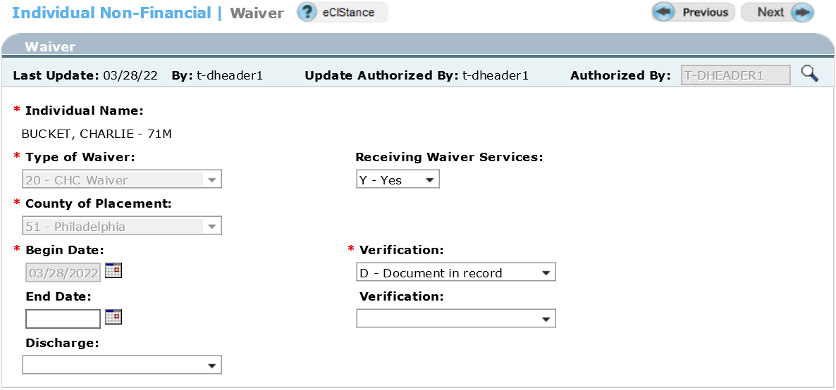
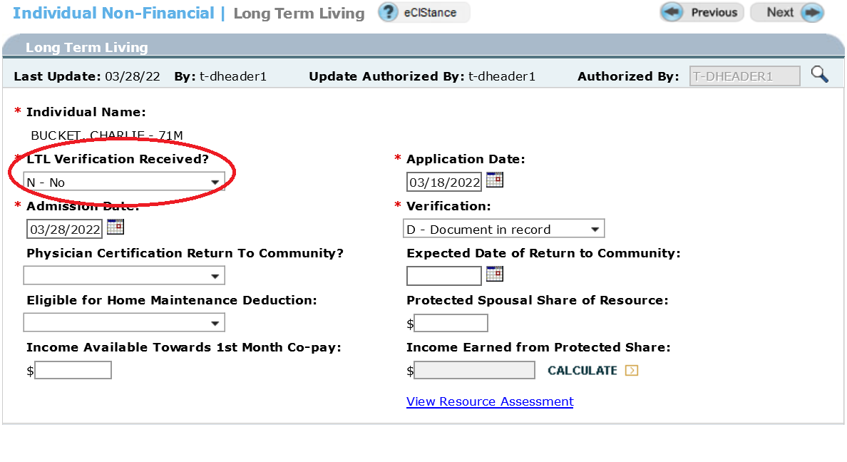
- On the Long-Term Living screen, enter an ‘N’ in the ‘LTL Verification Received’ field.
- Run eligibility. Case should fail a waiver category because the individual is not medically eligible.
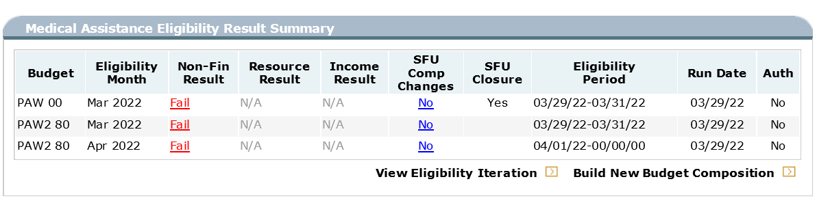

- Send system generated notice reason code 057, not medically eligible, to all involved parties.
- The IEB will send the applicant a notice of functional ineligibility for CHC and OBRA waiver applicants.

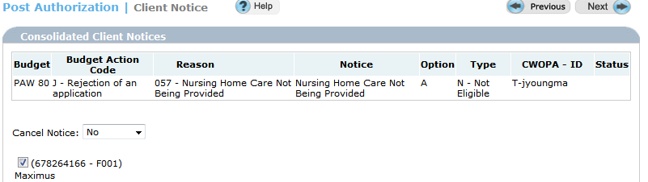
- Review for eligibility in a non-LTC related category of MA.

Adding HCBS to an Open SNAP Case
Waiver and SNAP benefits are to be opened in the same case record. When a recipient of SNAP benefits is determined eligible for HCBS the waiver category should be opened in the SNAP record using ‘Program Add’ mode.
- AP a ‘Medical Assistance Waiver’ category in the SNAP record.

- On the Case Summary screen choose ‘Program Add’ from the dropdown.
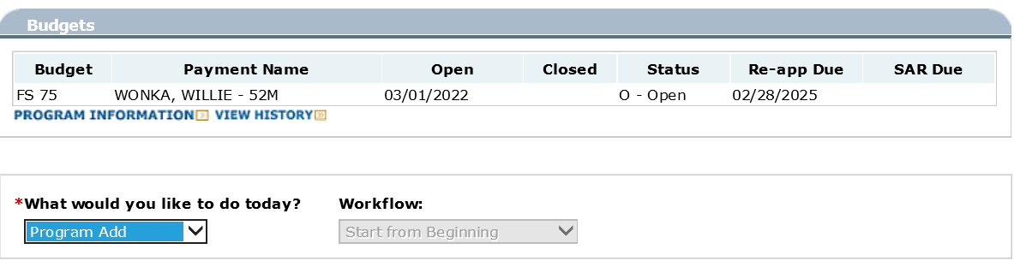
- On the Household screen enter a ‘Y’ to add a provider.
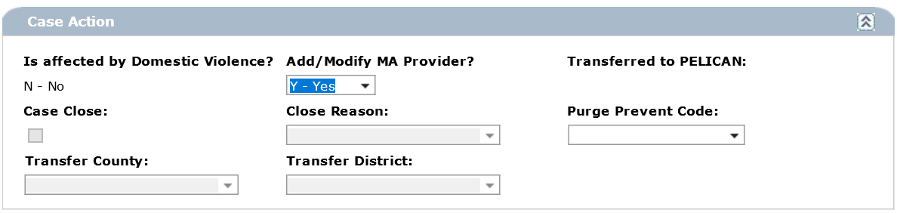

- On the Program Request screen edit the MA benefits. Enter the effective date and ‘Yes’ to process. Save this change.

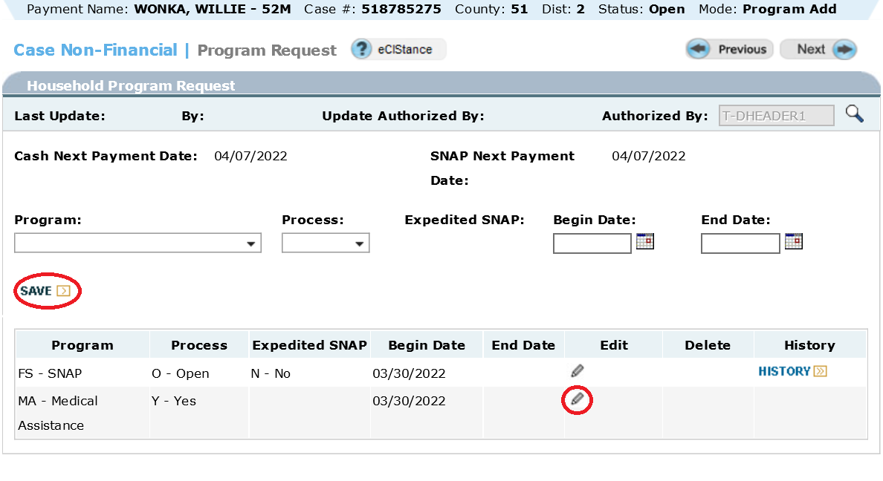
- Enter a Y on the Household screen to schedule the Provider screen.

- Enter information for all individuals and entities who need a copy of the notice on the Provider screen.

- On the Non-Financial Questions screen enter a ‘Y’ for ‘waiver’ and, if applicable, for ‘Disability’.
Reminder: If the individual is under age 65 then a ‘Y’ must be entered in the ‘Disability or Incapacity’ field and the Disability screen must be completed in order to build a waiver category.
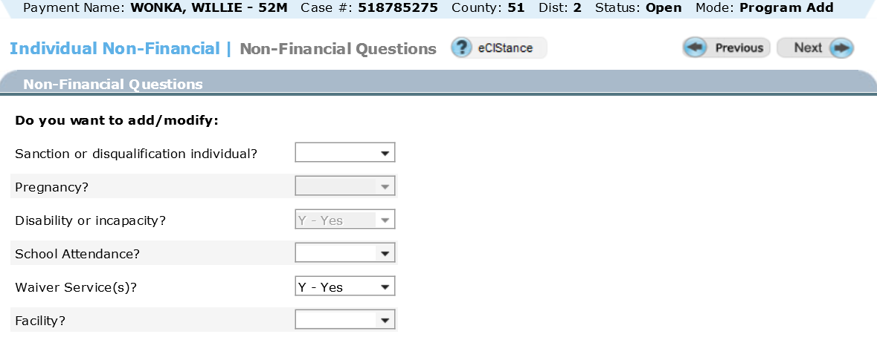
- Complete the Waiver and LTL screens with the appropriate information found on the PA 1768.

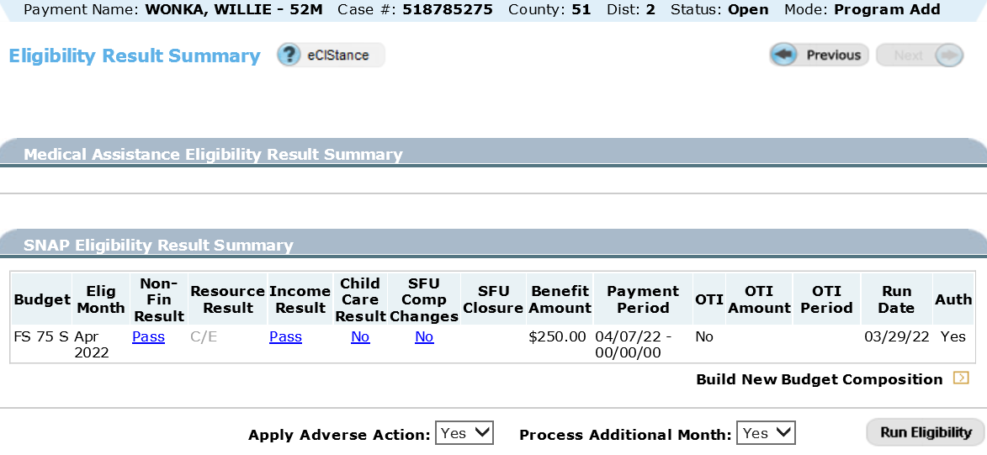
- Run eligibility. Eligibility will be determined in a waiver category and the SNAP benefit amount will be updated as appropriate depending on the financial information entered.

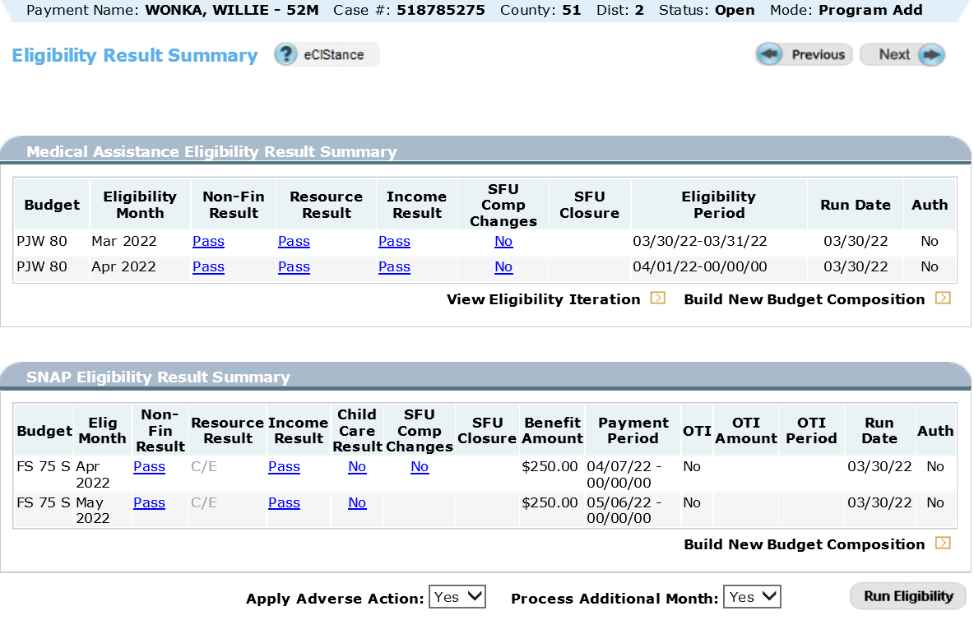
- A system generated notice of waiver eligibility and SNAP benefit changes will be issued.

AUTHORIZING HCBS IN A NON-LTC CATEGORY OF MA
In some cases, an individual is eligible for payment of HCBS but should be authorized in a non-LTC related category of MA rather than a waiver category. This section provides common examples of scenarios when the CAO may need to authorize in a MA category instead of a HCBS category.

Adult Community Autism Program (ACAP) Requests
ACAP is a capitated assistance program for adults who have a diagnosis of an Autism Spectrum Disorder (ASD). Currently this program is only available to adults living in Cumberland, Chester, Dauphin or Lancaster Counties. Authorization of ACAP in eCIS is designated by entry of waiver code 51. Unlike other waiver programs an individual applying for ACAP must not be authorized in a waiver category as the higher income and resource limits used to determine eligibility for other waivers is not applicable for ACAP. The CAO must review for eligibility in a Healthy Horizons or SSI-related category of MA. Individuals not financially eligible in one of these MA categories may be reviewed for eligibility in a Medical Assistance for Workers with Disabilities (MAWD) category if the individual agrees to pay the monthly MAWD premium. The CAO should process an ACAP application as a non-LTC related MA application. Waiver code 51 should be entered during authorization as it will not cause evaluation of eligibility in a waiver category. The CAOs handling ACAP cases should review the ACAP Information Memorandum for detailed information regarding ACAP including how to authorize benefits as well as the correct notice text and citations.

Spend-down Requests
If income of the HCBS applicant or recipient exceeds 300% of the Federal Benefit Rate (FBR) the CAO should explain SSI-related NMP MA and MNO MA spend-down options to the individual as outlined in MA Handbook Chapter Sections 368.4, 369.331, and 369.431.
NOTE: A person with excess income applying for HCBS cannot be determined eligible for payment of HCBS in an MNO waiver category.
If an individual with income exceeding 300% of the FBR chooses to spend-down to the NMP income limit (SSI income limits) in a PA/PJ/PM budget or MNO semi-annual income limit ($2550 for one-person or $2650 for two people) in a TA/TJ budget, the CAO should reject the waiver category, AP the case in an MA category, and process the case in a spend-down category of MA. After authorizing the case in the appropriate MA budget and program status code (PSC), the CAO should access the case through case maintenance to enter the appropriate waiver code on the Waiver screen. The category should NOT change to a waiver category but should remain a spend-down category of MA. See LTC Handbook Chapter 468.23 for more information regarding spend-down.
- Authorize in a spend-down category of MA using the paid and unpaid medical expenses discussed in LTC Handbook Chapter 468.23.

Non-LIFE HCBS
An individual applying for HCBS other than LIFE must be authorized in a monthly NMP spend-down category (PSC 21) or ongoing MNO spend-down category (PSC 22).
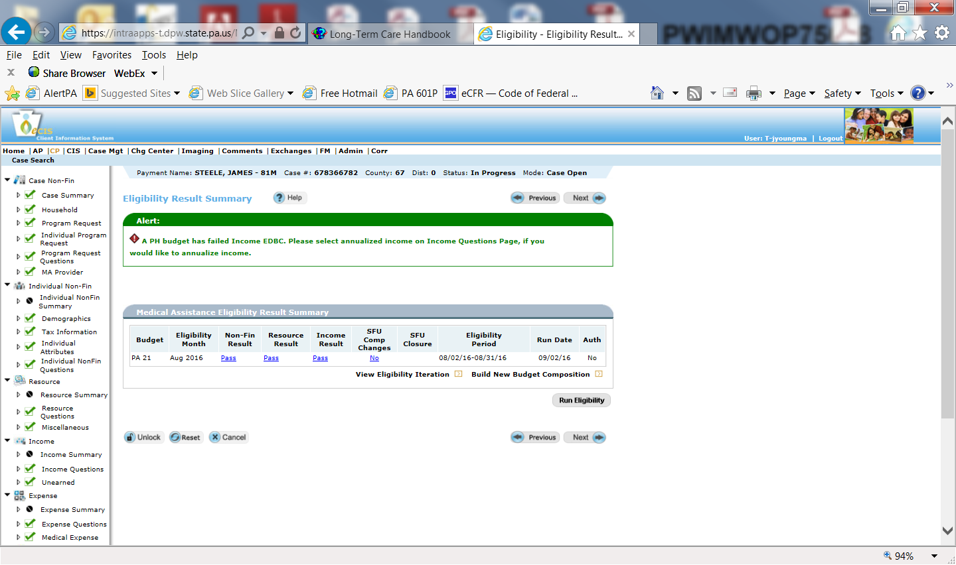
- After authorization of an ongoing MNO spenddown category, access the case through maintenance mode on the Case Summary screen.

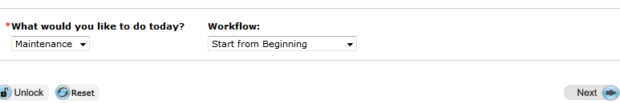

- On the Non-Financial Questions screen enter a ‘Y’ for ‘Waiver’.
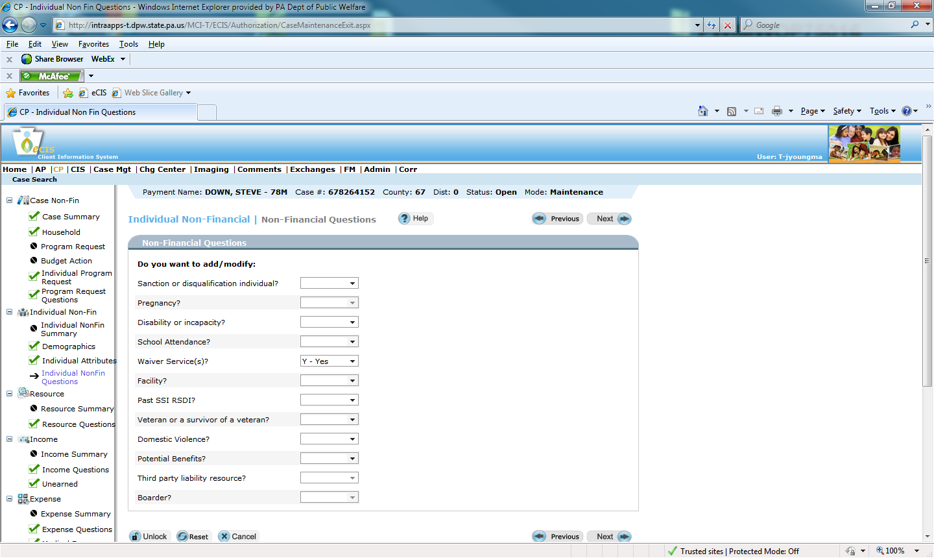
- On the Waiver screen enter the information from the PA 1768.
- Finish processing the case and run eligibility. The case should remain open in the spend-down category of MA.

LIFE HCBS
An individual applying for LIFE must be authorized in an ongoing NMP or MNO spend-down category (PSC 22).
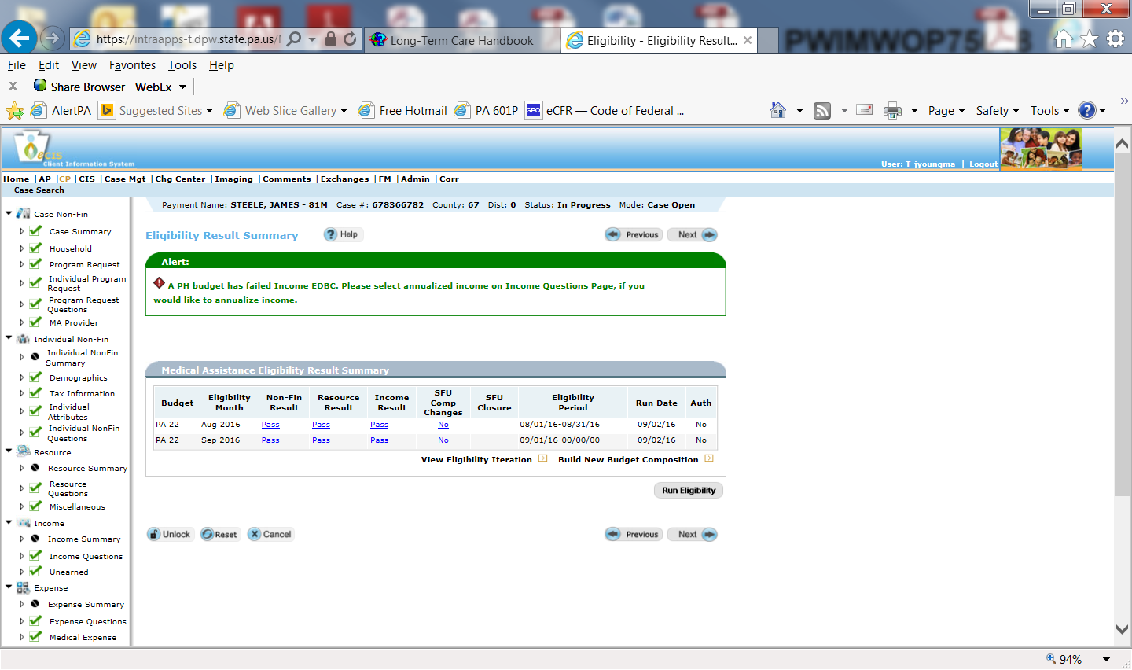

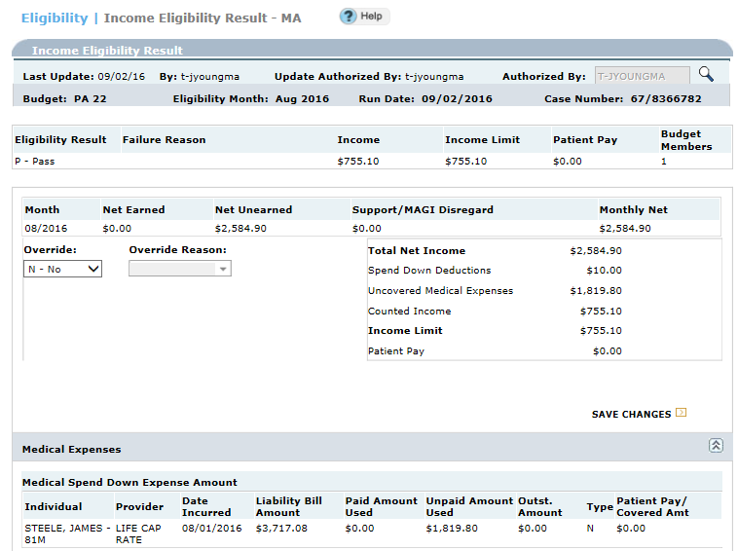

Income Eligibility Results screen continued:

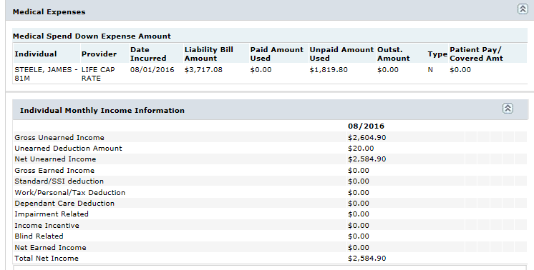

- Delete the system generated eligibility notice by deselecting the box under the ‘Issue’ field on the Client Notice screen.
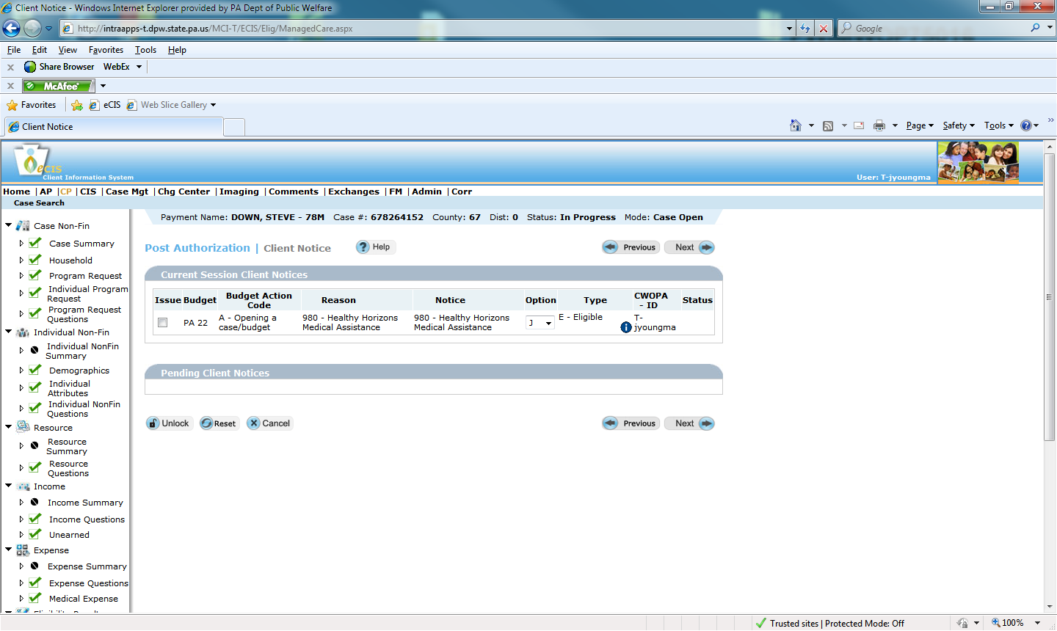
- After authorization, access the case through maintenance mode on the Case Summary screen.
- On the Non-Financial Questions screen enter a ‘Y’ for ‘Waiver’.
- On the Waiver screen enter the information from the PA 1768 using the LIFE Service Begin Date as the waiver begin date:
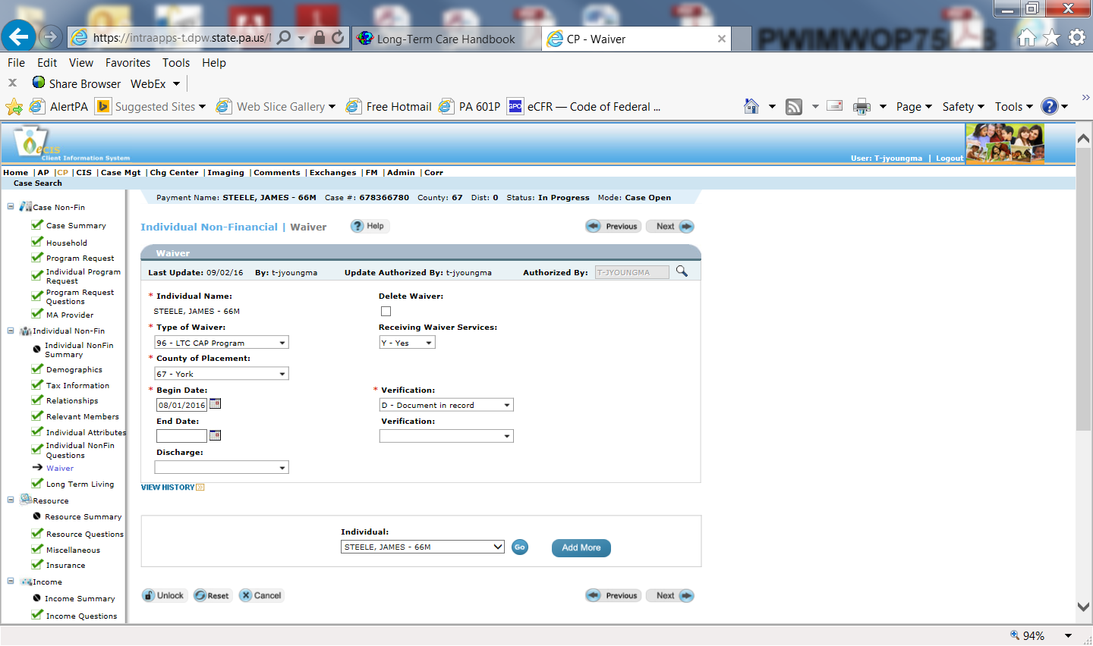
- Send a manual notice of spend-down and HCBS eligibility to all involved parties. See LTC Handbook Chapter 468, Appendix E for appropriate text and citations.

Non-Citizens Applying for HCBS
Temporary residents, undocumented non-citizens and certain qualified non-citizens who have not resided in the U.S. for at least five years are not eligible for payment of HCBS or LTC facility services unless they meet the conditions for Emergency Medical Services or the exemptions from the five year bar found in MA Handbook Chapter 322.321.
After it is determined that the individual has an approved emergency medical condition then the CAO will determine eligibility for payment of HCBS in a federally funded LTC category. The individual should only be authorized in a waiver category for the length of the emergency condition. For cases in which the emergency medical condition is expected to last less than five months an NCE should be entered on the Program Request screen.
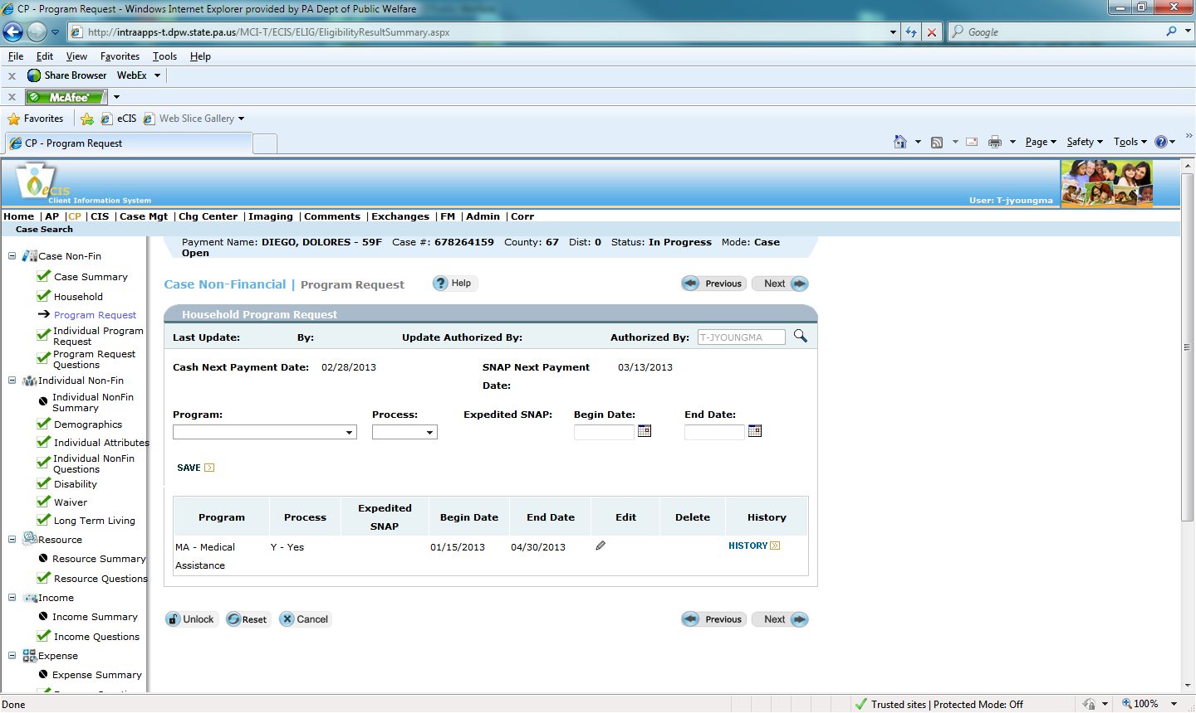
The CAO will authorize the waiver category making sure to complete the Alien/ Refugee screen with the correct U.S. entry date, country of origin, INS information and medical emergency information. The date the emergency began and is expected to end must be entered according to verification from the individual’s medical provider.

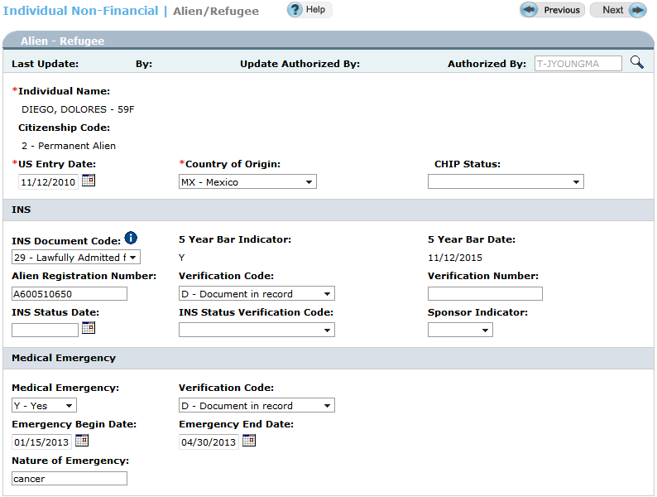
If the qualified non-citizen, temporary resident or undocumented non-citizen meets an emergency medical condition as well as all other non-financial and financial HCBS requirements then eCIS will authorize the individual in a waiver category.
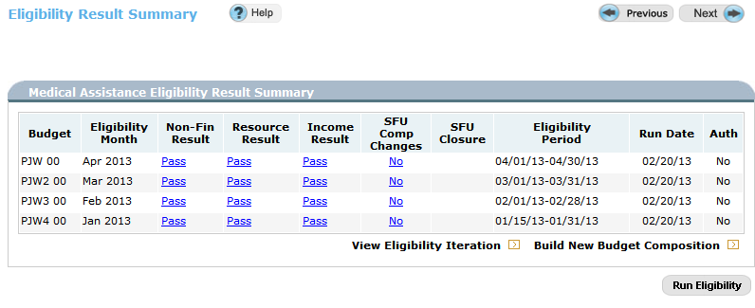

Once the emergency ends the CAO must review qualified non-citizens subject to the five year bar for GA-related MA eligibility. Once the emergency ends the individual is not eligible for payment of HCBS or LTC facility services. For more information regarding qualified non-citizens please see MA Handbook Chapter 322.3.

Entering a Waiver Code in an Open Disabled Adult Child (DAC) Case (Non-Financial Override)
Per Daily Status 3167 and MA Handbook Chapter 387.62, when an individual open in a DAC category (PA/PJ 81) is eligible for waiver services, the individual should remain open in a DAC category. The CAO should enter the waiver code in eCIS through maintenance mode. In some cases, upon entering the waiver code the category will change to a waiver category instead of remaining open in a DAC category. When this occurs a non-financial override needs to be processed.
When the CAO receives a PA 1768 for a DAC requesting waiver services the CAO will need to take the following actions in eCIS:
- Access the case through Case Maintenance mode.

- Enter a ‘Y’ for ‘waiver’ and, if under 65 years of age, a ‘Y’ for ‘disability’.

- Complete the Disability, Waiver and Long Term Living screens.

- Run eligibility. In most cases the DAC category will fail and the waiver category will pass. When the waiver category passes a non-financial override must be completed.

- Change the SFU status for each month by clicking on the SFU Comp Changes link, one month at a time.
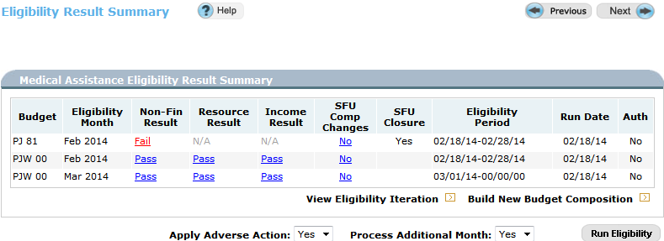
- On the Budget Composition screen change the SFU status to ‘NA’, enter a ‘Y’ for a composition override and choose reason 901. Save the changes.
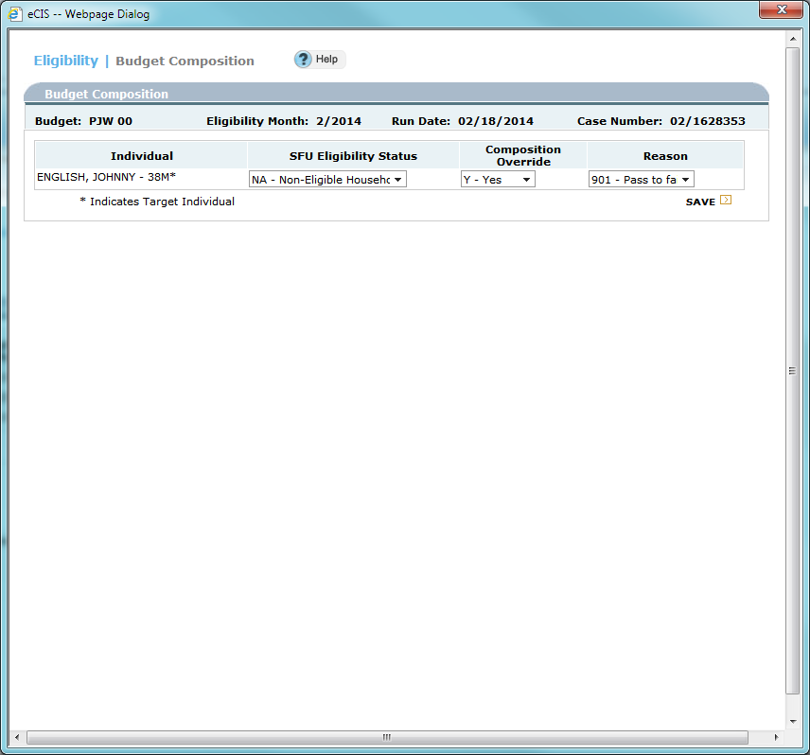
- Repeat the same budget composition changes for the second month. Run eligibility. This action will cause the PJW category to fail.
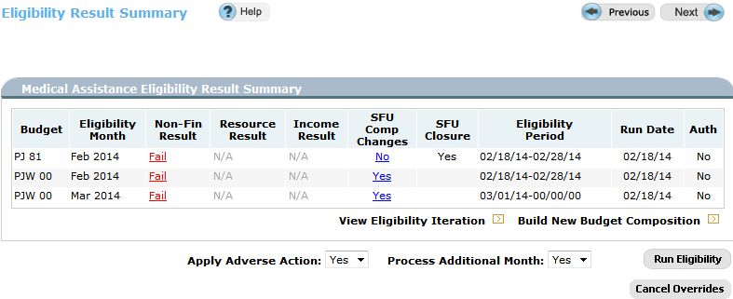
- Click on the Build New Budget Composition link. On the Build New Budget Composition screen enter the DAC category, program status code, grant group (leave blank if grant group is one) and effective dates. Enter the appropriate SFU Eligibility Status, a ‘Y’ for the composition override and reason ‘900-fail to pass system logic deficiency’. Save the changes.
NOTE: The CAO can either choose to build a new budget composition for each month eligibility was determined or can choose to build a new budget composition for one month ongoing. In this example, the CAO could either build a budget composition for 2/18/14 through 2/28/14 and then a second budget for 3/1/14 ongoing or could simply build the budget effective 2/18/14 ongoing. The begin date must be the process date or the first day of the calendar month following the process date. As long as the correct waiver code is entered on the Waiver screen, providers will be able to bill.
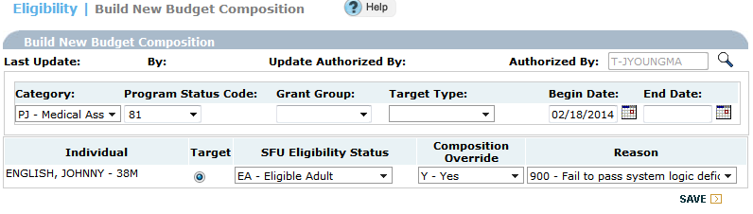
- Run eligibility. The individual will be authorized in a DAC category with an open waiver code.
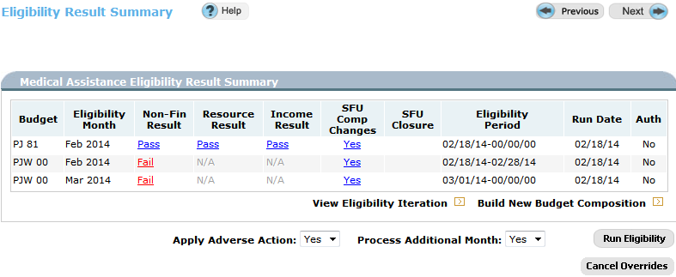
- Send manual notice of eligibility for waiver services to all involved parties effective the date entered on the Waiver screen.

Authorizing HCBS Applicants in a Medical Assistance for Workers with Disabilities (MAWD) Category
Individuals requesting payment of HCBS may be eligible to receive waiver services in a MAWD category if MAWD eligibility requirements are met. This may be a beneficial option to a HCBS applicant because the income and resource limits are higher for a MAWD category than a HCBS category. However, MAWD recipients must pay a monthly premium. Premium payments should be discussed with the HCBS applicant prior to authorizing in a MAWD category. For more information regarding the MAWD program, including eligibility requirements, see MA Handbook Chapter 316.
- Authorize in a MAWD category (PW or PI) without entering any waiver information. When authorizing in the MAWD category the Disability screen must be completed. On the Disability screen enter a ‘1’ in the ‘MAWD Request’ field and answer the ‘MAWD Eligibility begins next month’ question. In order to be eligible for MAWD the individual must be working so the Employment/Wage screen must also be completed.
NOTE: Entry of the waiver code while processing the case will cause a waiver category to fail for excess resources or income. The waiver code must be entered through maintenance AFTER the MAWD category is authorized.

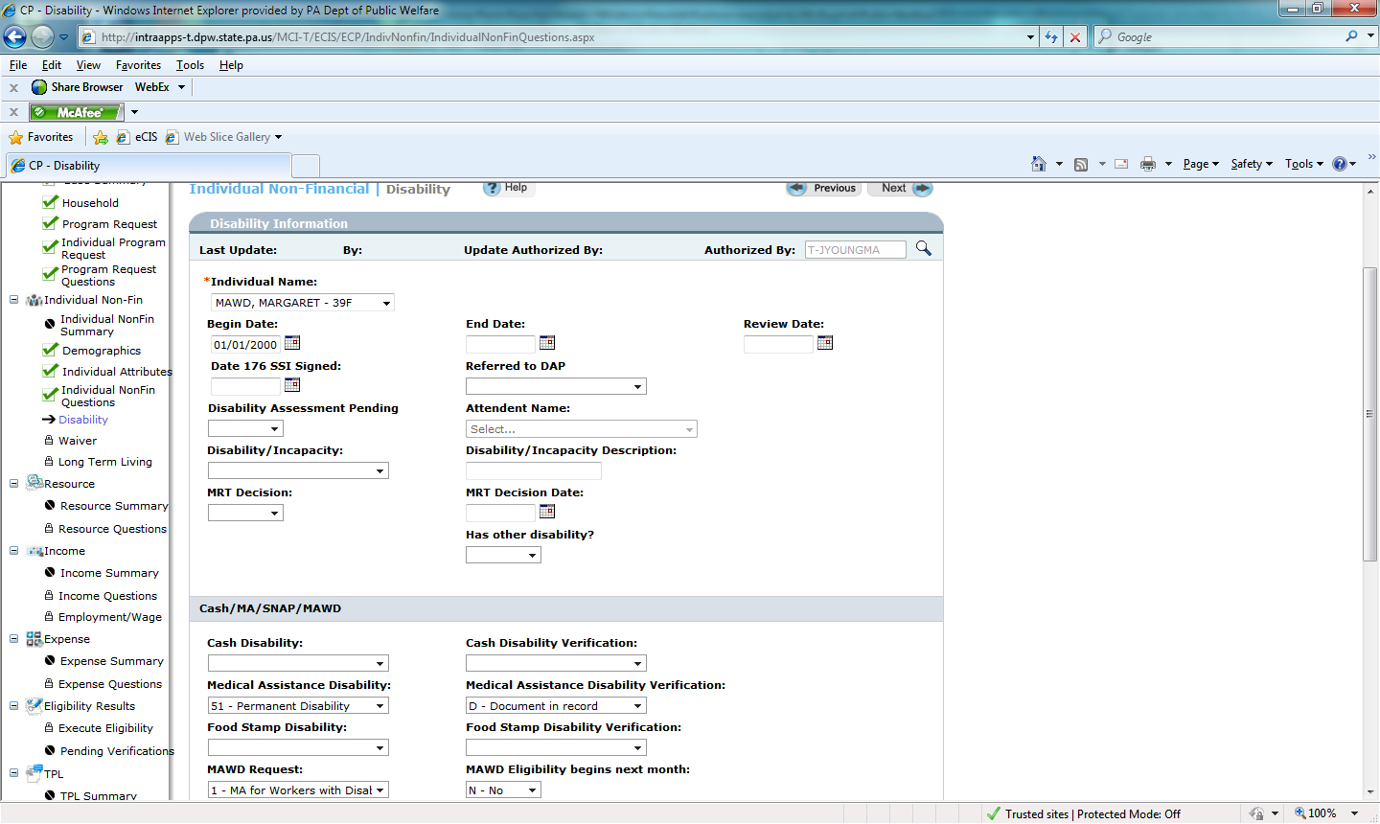
- Through maintenance mode, access the Individual Non-Financial questions screen and enter a ‘Y’ for waiver.

- Enter appropriate waiver information on the Waiver and LTL screens.

- Run eligibility. Case should remain open in a PW or PI category with the waiver code information entered.

- Send a manual notice of HCBS eligibility to all involved parties.

Establishing a Penalty Period
When an applicant or recipient of HCBS transfers assets during the look-back period for less than fair market value (FMV), an ineligibility period for payment of HCBS must be established. The total uncompensated value is divided by the average daily private pay rate in effect at the time of case processing.
Reminder: The penalty period is determined using the average LTC facility daily private pay rate in effect at the time the case is processed.

HCBS Applicants
For individuals applying for HCBS who are not recipients of MA the look-back period is based on the application date. The application date is the date the application was received in the CAO or, for provider applications, the date the provider signed the application is the date used to determine the look-back period.
For current MA recipients who are applying for payment of HCBS the look-back period begins five years prior to the assessment date listed on the PA 1768. In order to determine the penalty period due to an asset transfer the assessment date should be listed as the application date on the Long Term Living screen.
Example: John is applying for HCBS. The CAO receives a PA 1768 on 7/1/22. The PA 1768 verifies medical eligibility for the CHC Waiver. The assessment date is 6/24/22. The assessment date of 6/24/22 is listed in the ‘application date’ field on the Long Term Living screen. The processing date is listed in the ‘admission date’ field. The look-back period begins 6/24/17.

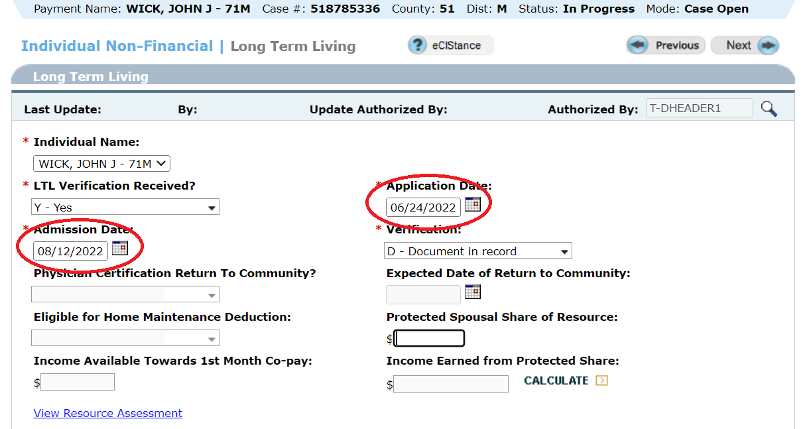

In order to enter asset transfers of a HCBS applicant at authorization:
- Enter a ‘Y’ in the ‘LTL Asset Transfer’ field on the Resource Questions screen.
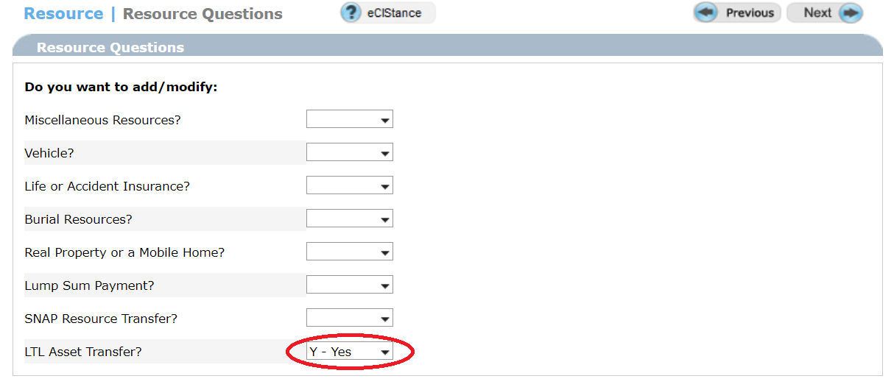

- Enter the appropriate resource code, transfer date, to whom the resource was transferred, market value and percent owned for each asset transfer. If appropriate, enter the amount owed and amount received. To add additional asset transfers use the ‘Add More’ button. Enter the amount owed and amount received if applicable. In the screenshot below non-resident property was transferred on 11/15/19. The property was valued at $72,600 but only $20,000 was received.

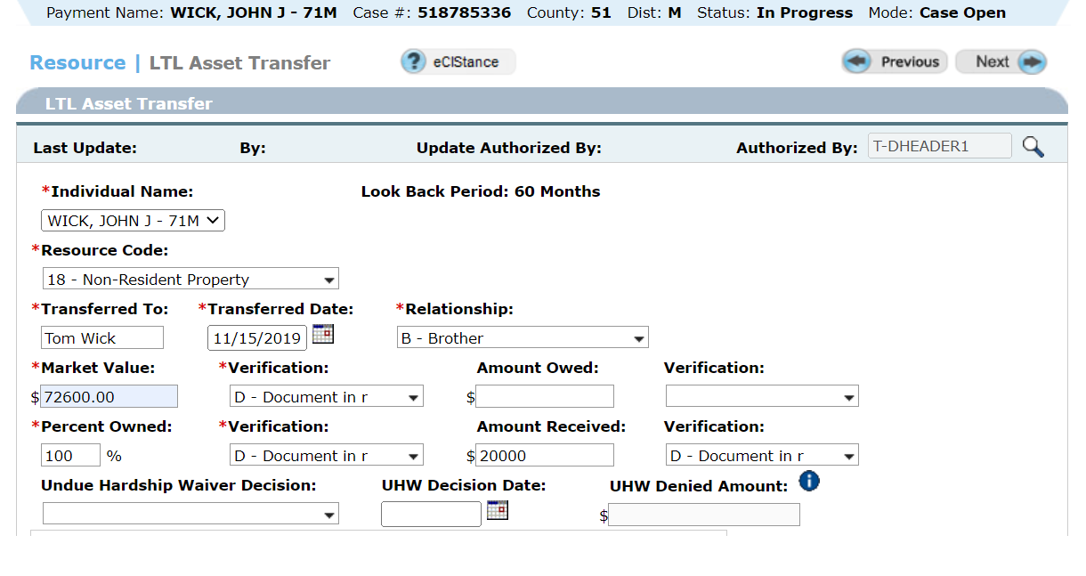
Reminder: Each asset transfer should be entered on a separate LTL Asset Transfer screen.

- Always review the Resource Eligibility screen and the Individual Insurance Type screen to verify the correct 903Q disqualification period was established.

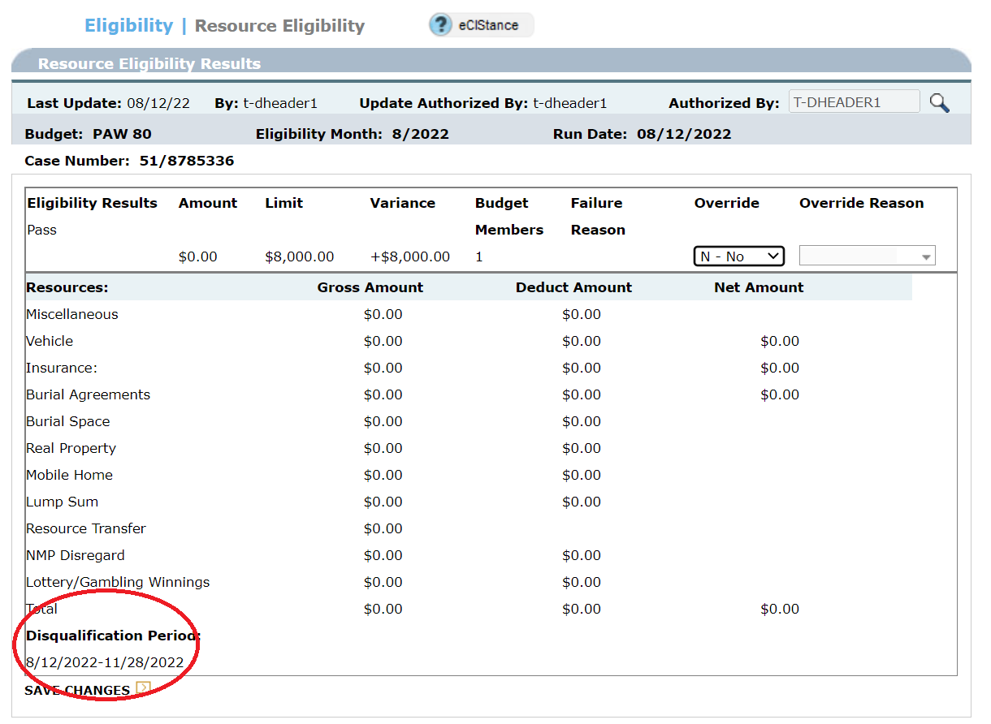
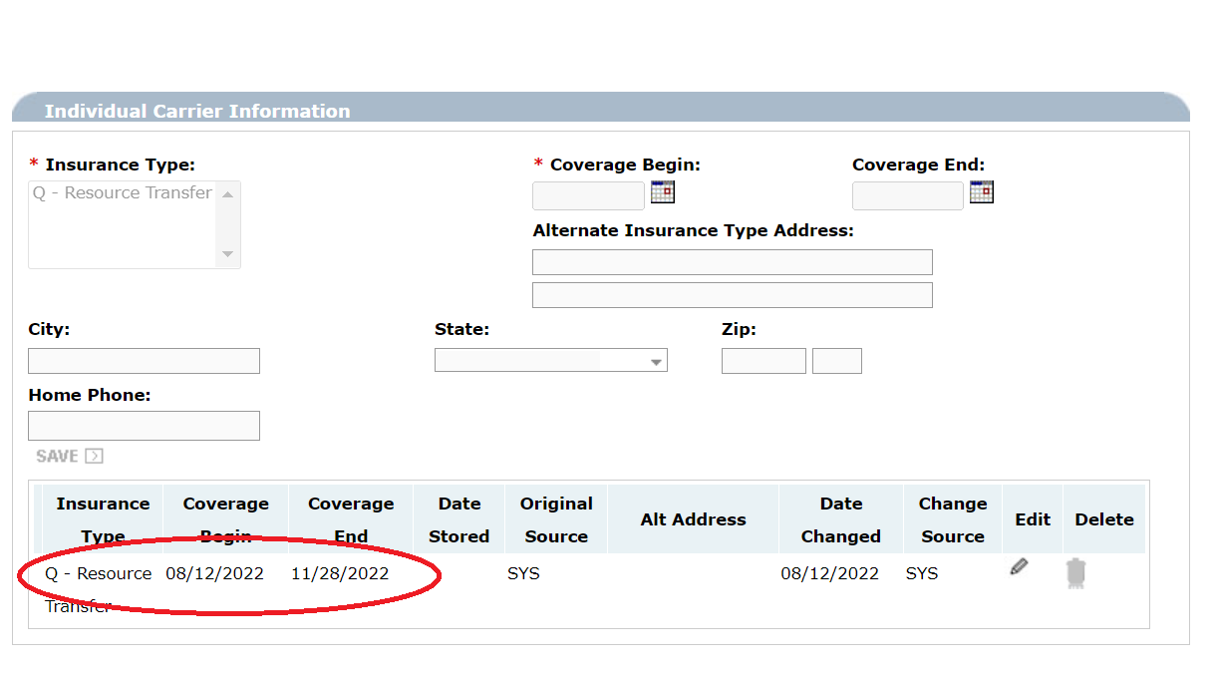

The system will then send a 986 L notice to the applicant and any other applicable parties.
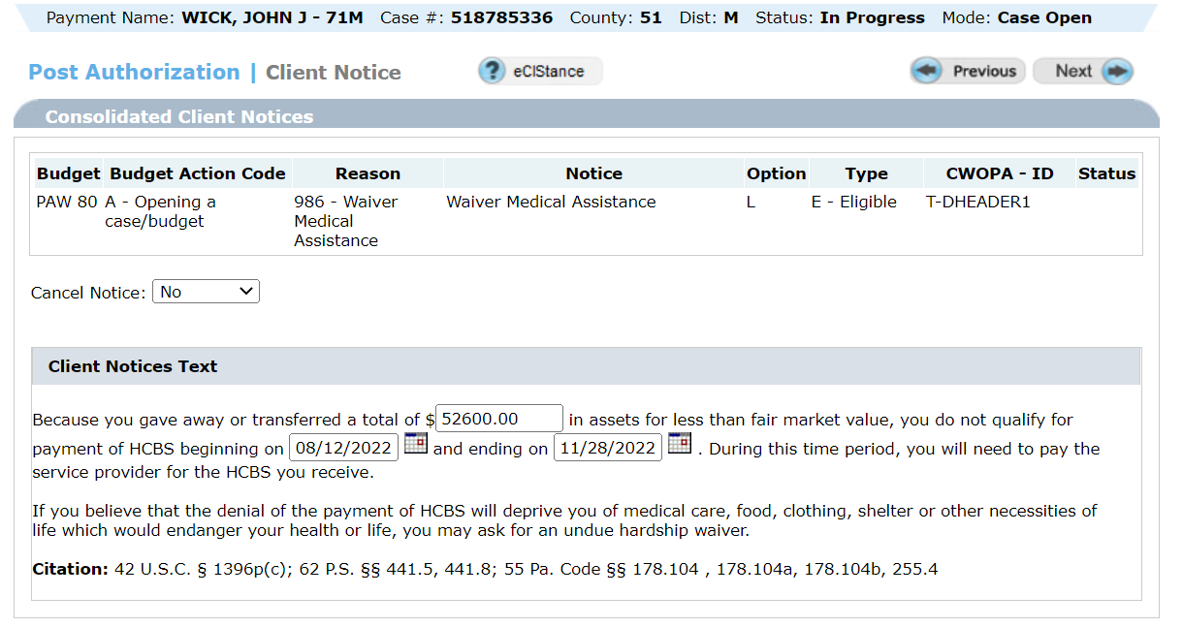

HCBS Recipients
When a recipient of HCBS transfers assets during the look-back period an ineligibility period for payment of HCBS must be established. The total uncompensated value is divided by the average daily private pay rate as of the time of processing.
For HCBS recipients the effective date of the ineligibility period is the first day of the calendar month AFTER fifteen day advance notice expires.
Example: Tyler is a recipient of HCBS. It is discovered that Tyler transferred a non-resident property valued at $72,600 to his brother on 11/15/19, and received $20,000 in compensation. That leaves $52,600 without fair consideration. The asset information was entered in eCIS on 7/29/22. Fifteen day advance notice expires on 8/13/22. Therefore, the 903Q penalty period begins 9/1/22; the first day of the calendar month AFTER fifteen day advance notice expires.
- Access the Resource Questions screen through case maintenance and enter a ‘Y’ in the ‘LTL Asset Transfer’ field to schedule the LTL Asset Transfer screen.

- Enter the asset transfer information on the LTL Asset Transfer screen.

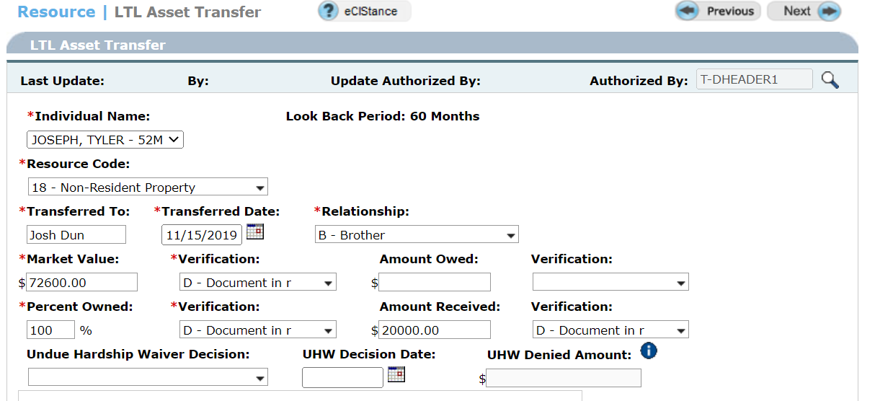

- After running eligibility review the Resource Eligibility screen. ECIS will calculate the disqualification period using the current average daily private pay rate as of the date of processing.

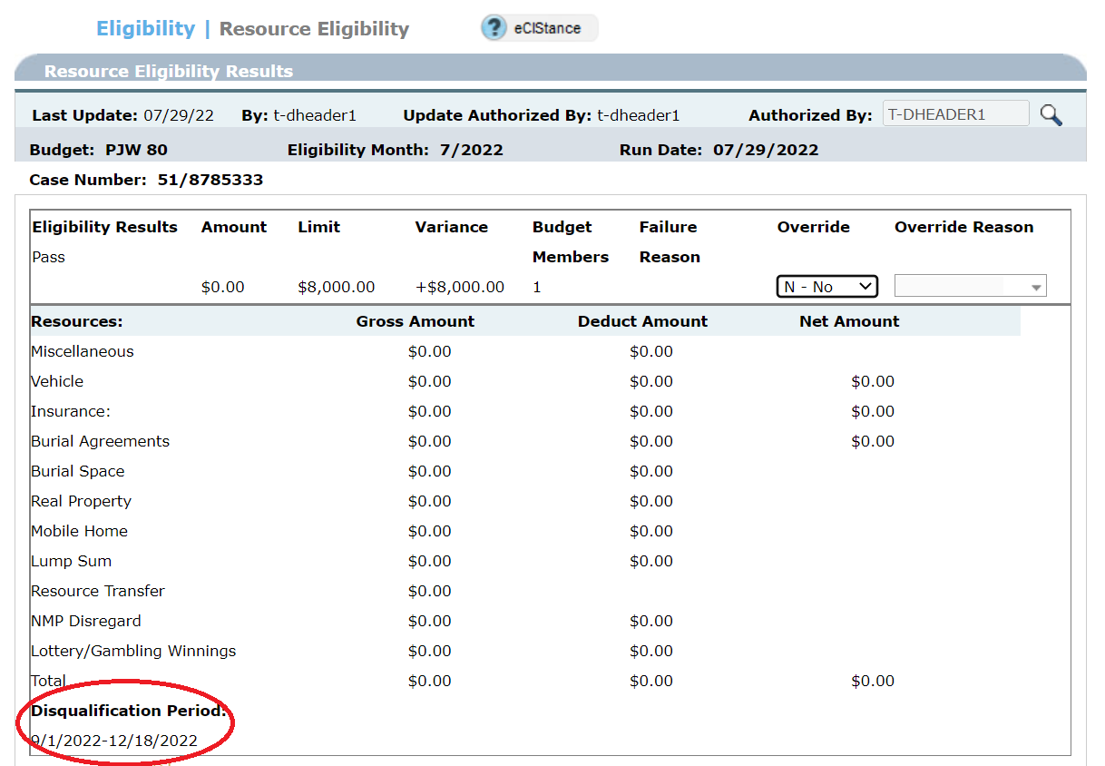

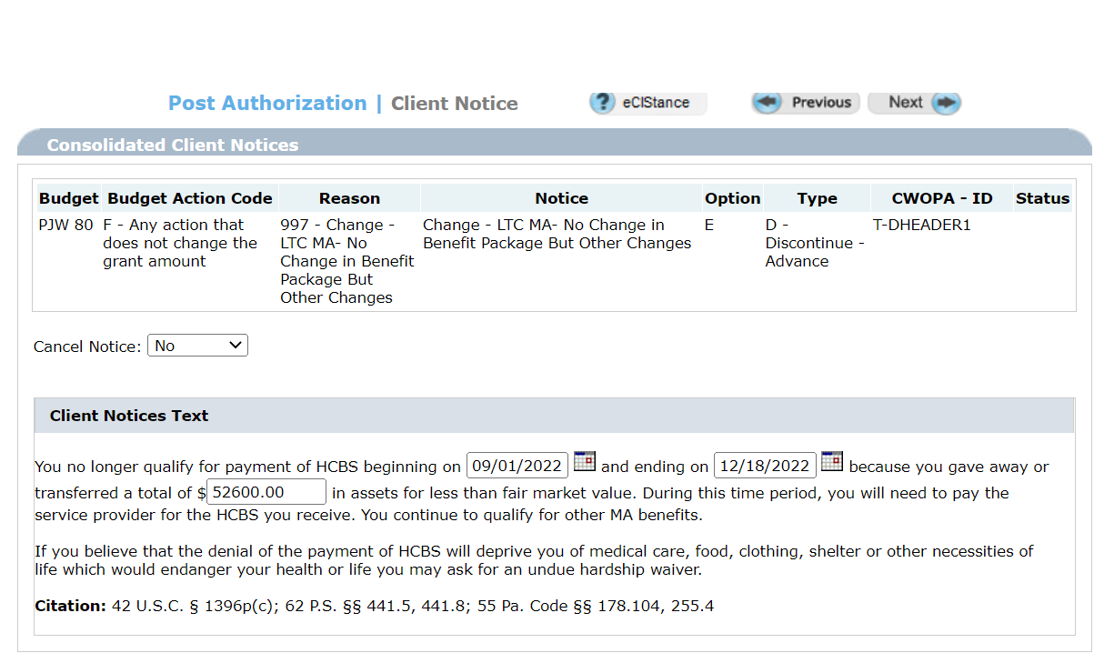

- eCIS will systematically enter the 903Q TPL.

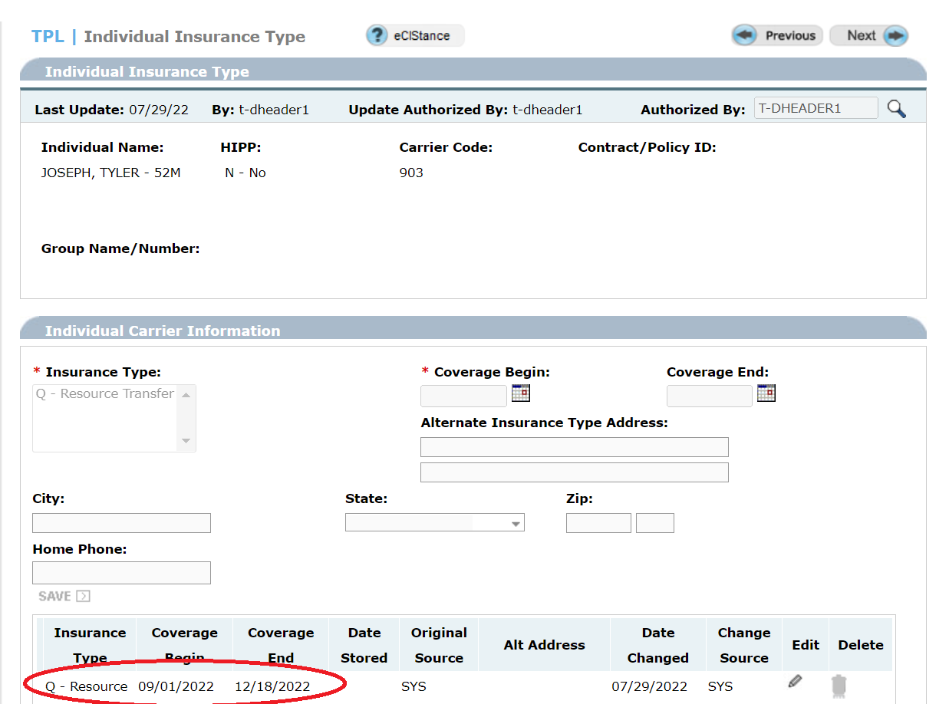

Manual Adjustments to the 903Q TPL
The 903Q TPL is created when a penalty period is established. While a penalty period is in effect the individual is eligible for all services covered under MA but is not eligible for payment of waiver services. The purpose of the 903Q penalty period TPL is to block the HCBS provider from billing for waiver services while allowing MA providers to bill for non-waiver related medical services.
Although the system usually determines the correct penalty period there are a few instances when the 903Q must be adjusted manually. Some of these instances include negation of the 903Q when a transferred asset is returned,
- modification of the 903Q when the asset is partially returned causing a reduced penalty period,
- modification of the 903Q when the penalty period has already expired,
- modification of the 903Q on a case in closed status,
- modification of the 903Q on the case of an institutional spouse (IS) with an existing penalty period when their community spouse (CS) enters a LTC facility because the penalty must be split between them,
- modification of the 903Q based on a BHA adjudication.
These changes are to be made using the ‘standalone’ module in eCIS.
Example: At HCBS authorization a penalty period from 8/12/22-8/31/22 was established for an asset transfer. A portion of the asset was returned to John, resulting in a shortened penalty period, requiring a manual adjustment to the 903Q Transfer Penalty TPL.
- Access the ‘TPL Summary’ in the Standalone Module
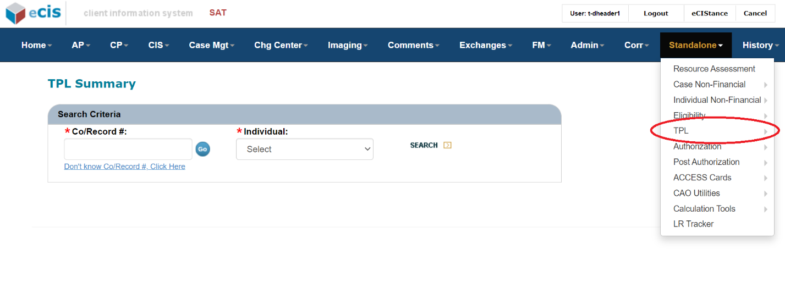
- Enter the case information and click ‘search’
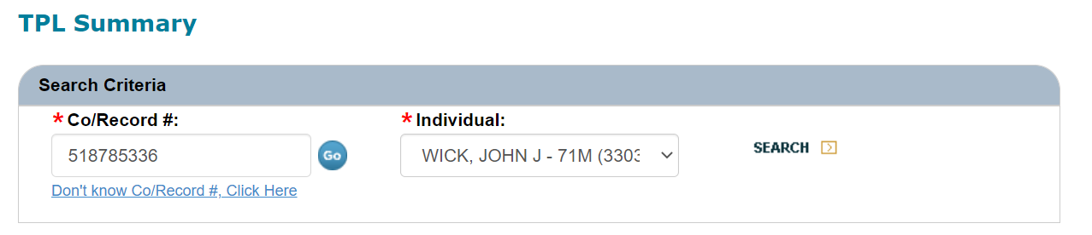
- Click on ‘903-Transfer Penalty’ then click ‘next’.
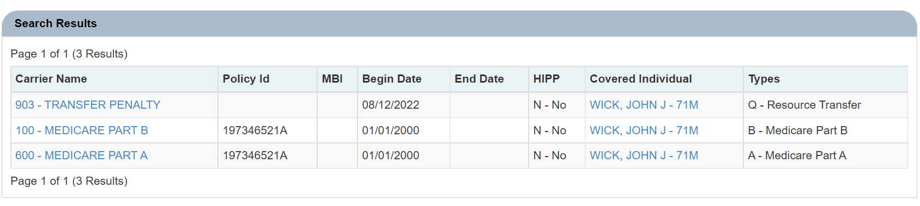
- Click ‘edit’.
- Enter the new transfer penalty date and click ‘save’.

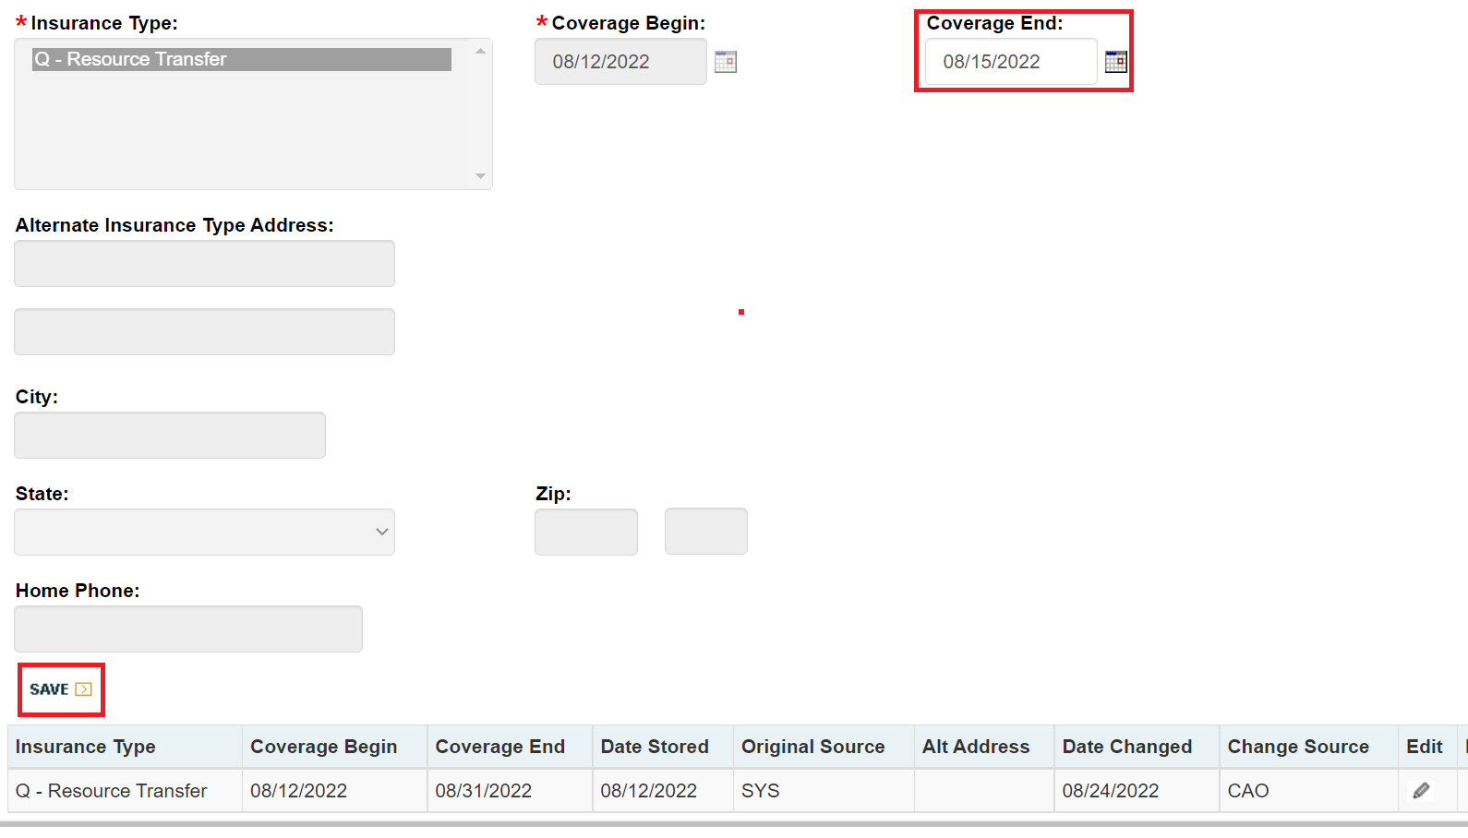

- Assure your results are correct.
- If the adjustment of the 903Q TPL is due to an Undue Hardship decision, please refer to the ‘Undue Hardship Waiver Notices’ section.
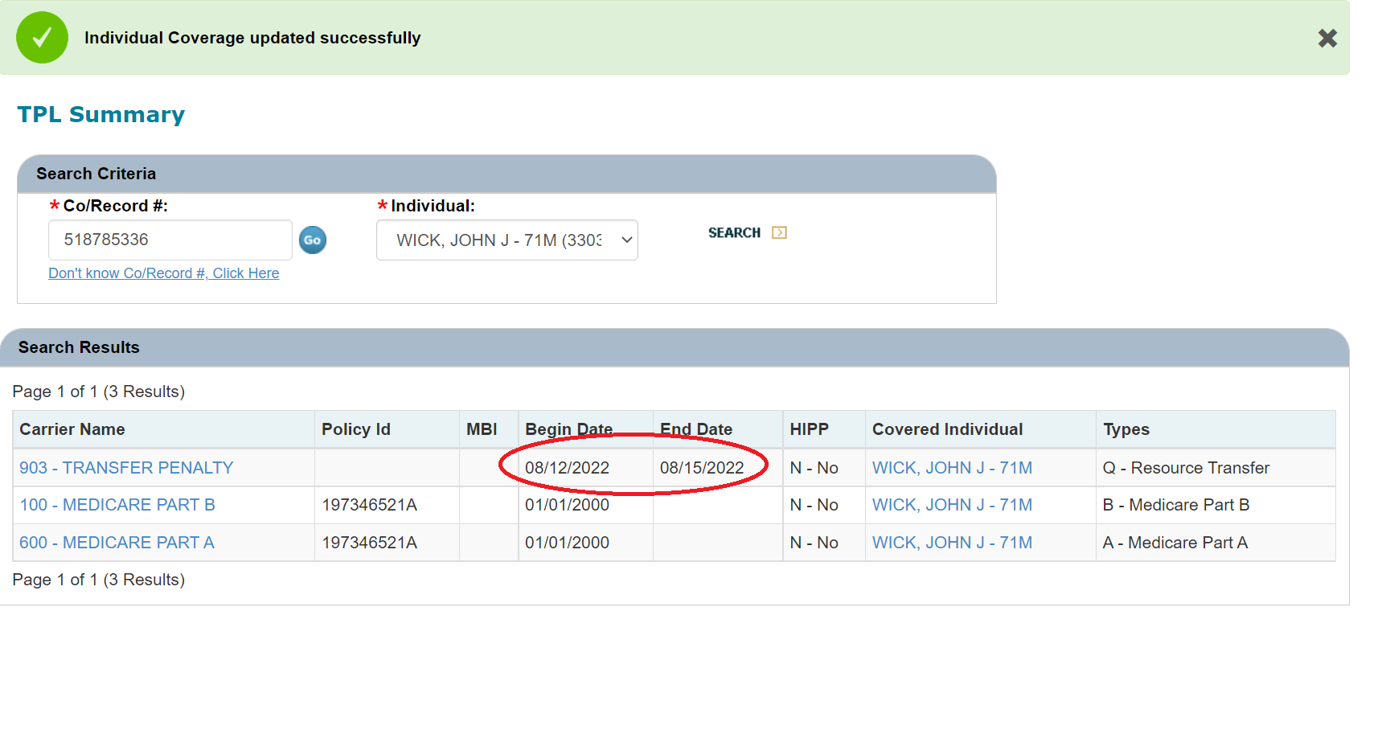

MANUAL NOTICES
System generated notices should be sent when available because the system generated notices contain the appropriate citations and all pertinent information in language that is easily understood. Unlike manual notices, the date system generated notices were processed and mailed is easily documented. However, until system enhancements are made, there are some instances when a manual notice must be generated.
The CAO will take the following steps when sending a manual notice:
- send a copy of the notice to the individual, individual’s representative(s), and the IEB or assessing agency listed on the PA 1768; and
- narrate when a manual notice is sent and to whom copies are sent; and
- scan a copy of the notice to the record.
Below are some common instances when a manual notice must be sent:
Scenario: | Location of text and citations:
Authorizing HCBS in a MAWD category | Send a system generated notice of MAWD eligibility. Send a manual notice of HCBS eligibility using reason code 986, option B from the CIS TENG table.
Authorizing HCBS in a spend-down category of MA | LTC Handbook Chapter 468, Appendix E
Authorization or termination of ACAP | ACAP Information Memorandum issued to ACAP counties

Reminder: When processing a transfer from one HCBS program to another the CAO must send a system PA 162 notice to all involved parties, including both the losing and gaining service providers.
Undue Hardship Waiver Notices
When an individual is penalized for a transfer for less than fair market value (FMV) or excess home equity, they have the option to request an Undue Hardship Waiver (UHW) see LTC HB 440.89.
When the CAO is notified of the Department’s decision to approve or deny the UHW, the CAO must take appropriate action. System enhancements have been implemented to allow eCIS to send system notices in these instances instead of manual notices.
- When the PA 1855 is received by the CAO, the worker must go into the LTL Asset Transfer screen through maintenance mode and complete the appropriate decision fields and click ‘next’.
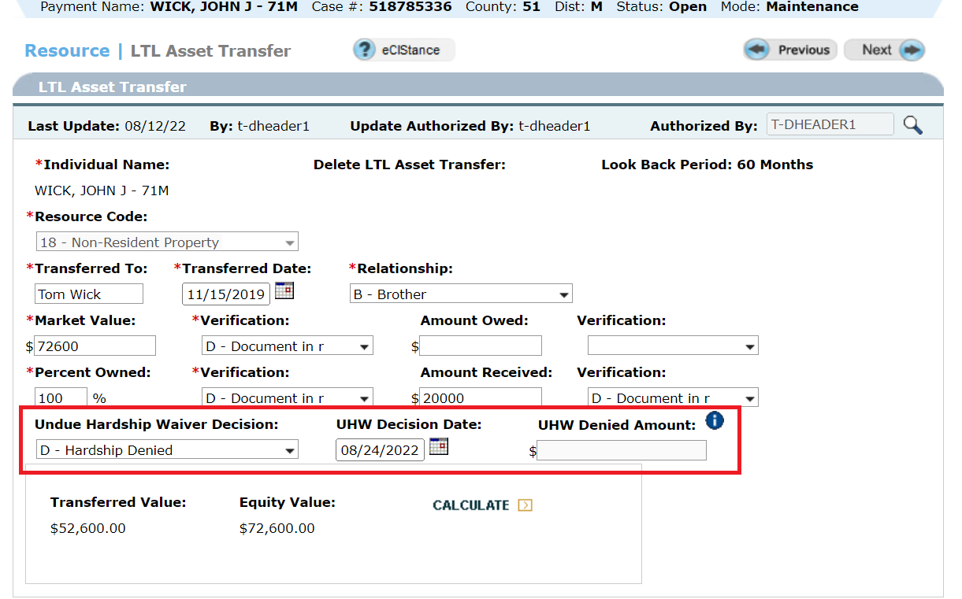

- Run eligibility.
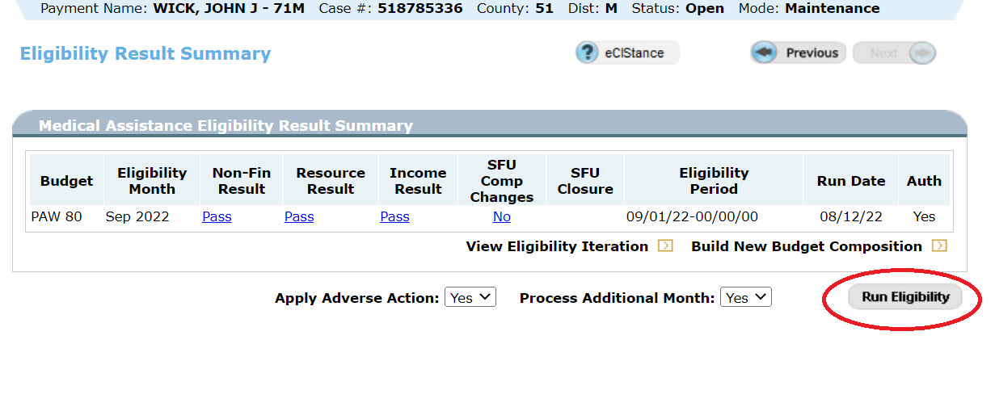
- If the UHW is denied, the transfer penalty and 903Q TPL will remain in eCIS.
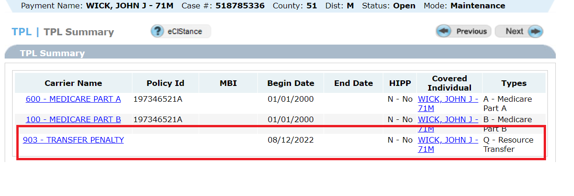
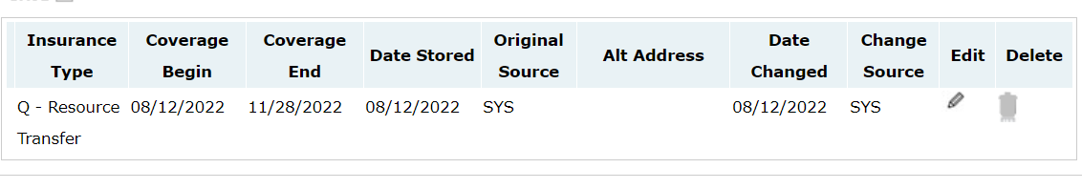
- The system will then generate the appropriate notice.
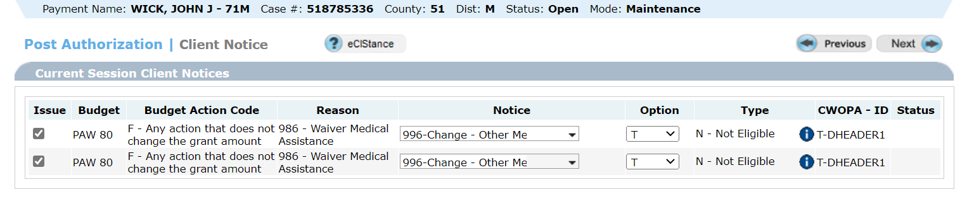

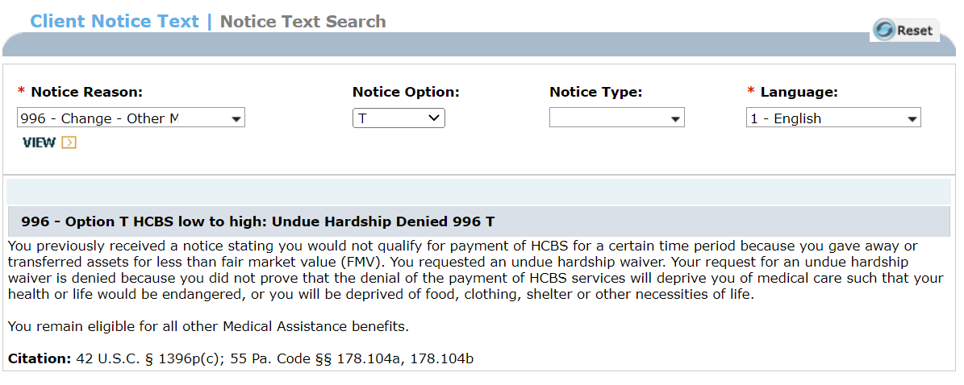

- If the UHW request is approved or partially approved, the CAO is to follow the same steps above.
- eCIS will generate the appropriate notice.

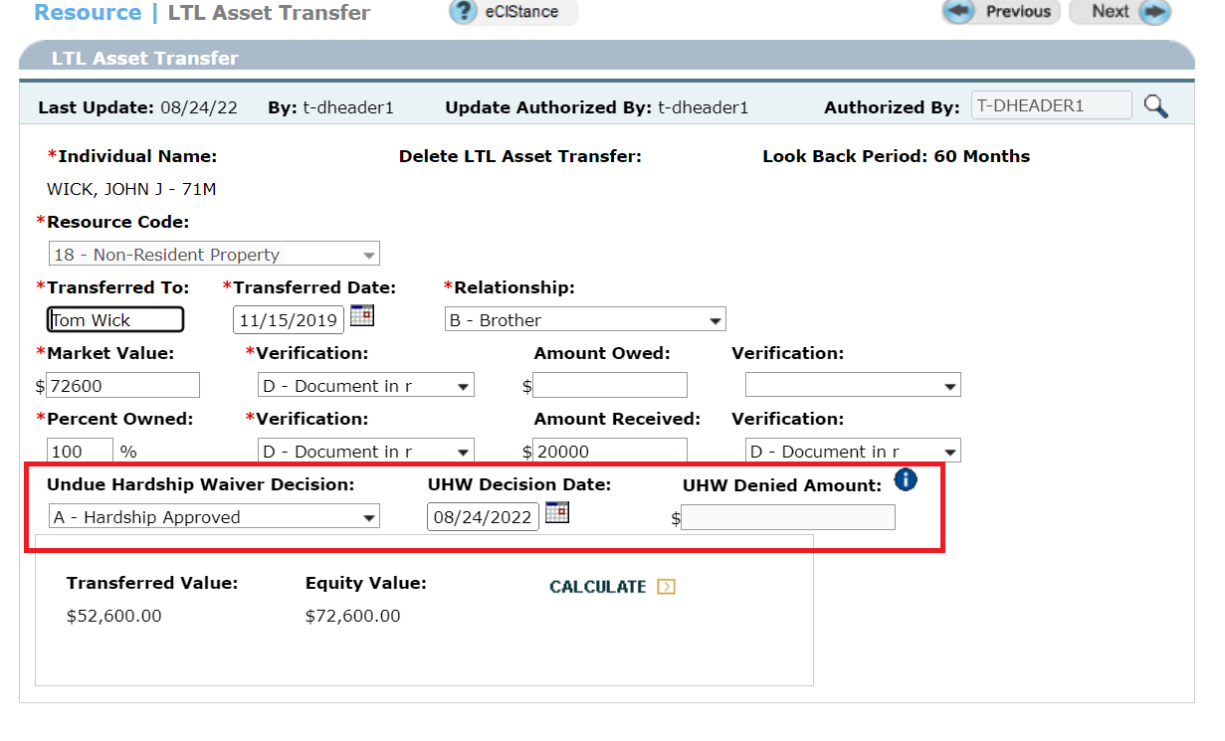

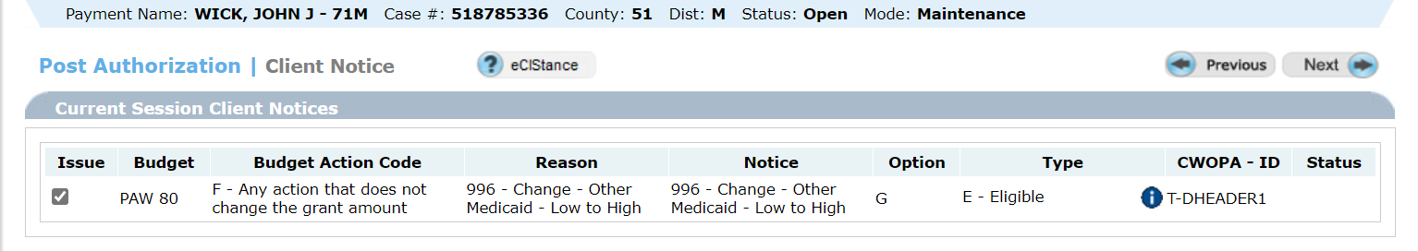
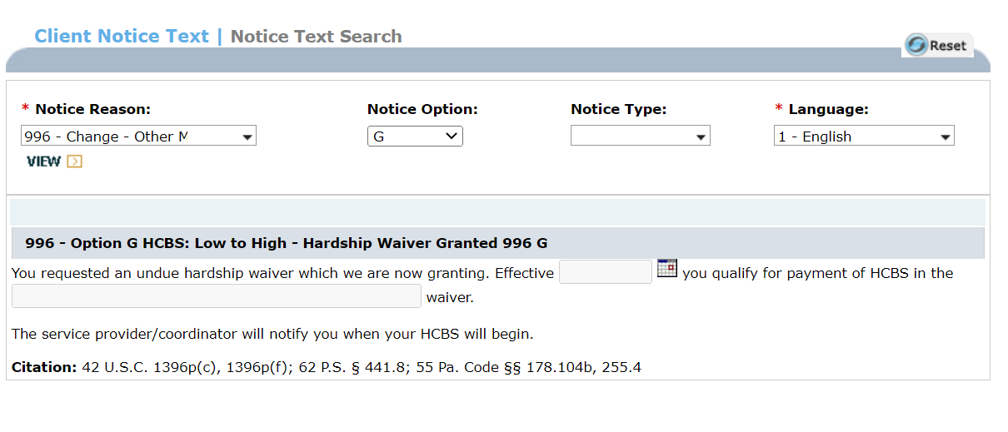
- When a partial approval is received by the CAO and the above steps are followed, eCIS will also calculate the new penalty period and 903Q TPL.
